Ellaine Fontamillas

1923636

Introduction to Programming using C++

End Assessment

C6-IPC-11

Faculty of Computing

**Table of Contents**

1. Introduction
2. Analysis
3. Design
4. Implementation
5. Conclusion
6. Reference

**1. Introduction**

This project creates a student report card system for St. Peter international school using code::blocks application. The users (teachers) have issues manually recording their students’ records.

This project helps in their issues.

**2. Analysis -** Core Requirements

* User Requirements:
* Teachers want to:
* Create student record for each individual attending his/her class
* Remove existing record
* Modify existing record
* Search existing record
* Capture marks for individual subjects
* Calculate and Display results
* System Requirements:
* Must auto generate the student ID
* Should provide provision to view class results
* Calculate class average
* Must help teachers accomplish their requirements
* Must calculate marks and result
* Display results
* Must be user friendly, easy to use
* 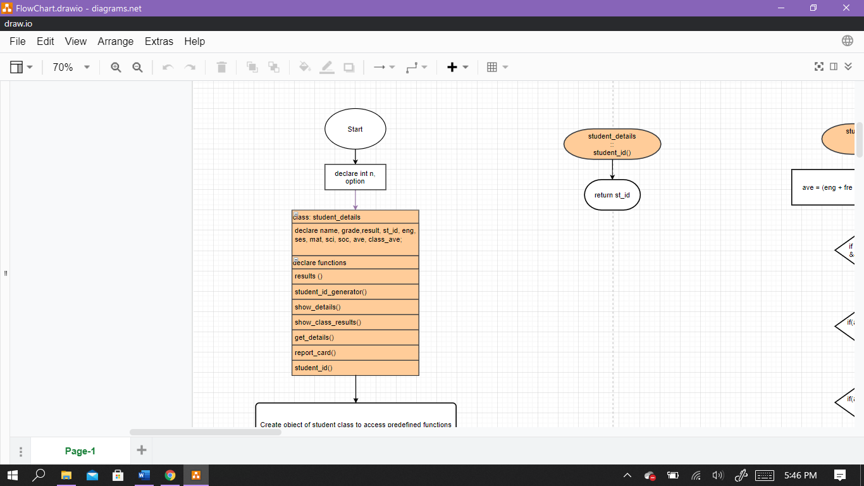Should have appropriate menus to navigate through from one window to another

**3. Design – Algorithm**

**and Flowcharts**

Algorithm for student report card

Input: options, student number, name, marks, average, class average yes, no, grade

Output: Report card, class results, name, marks

Step 1: start

Step 2: declare options, student_number, name, English, French, Sesotho, maths, science, social, average, class average, grade

Step 3: display” main menu

Option 1: Create record

Option 2: Generate student report card

Option 3: Delete record

Option 4: Modify record

Option 5: Search record

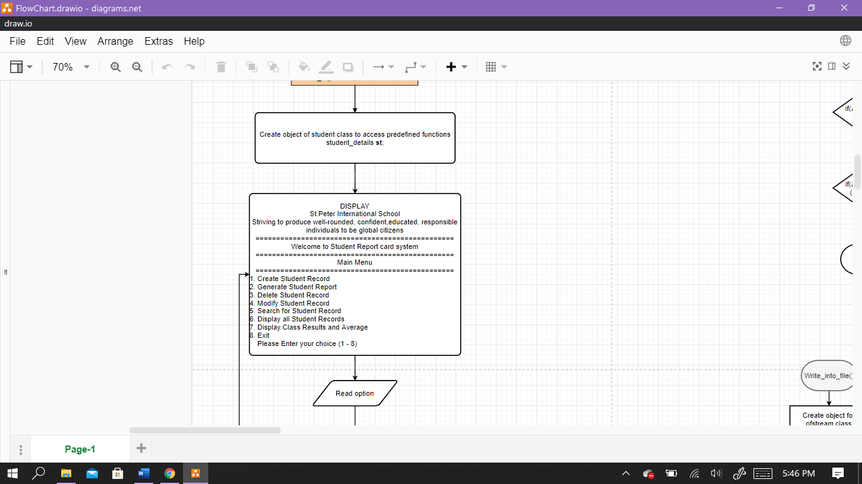

Option 6: Display All record

Option 7: Display Class Results

Option 8: exit”

Step 4: accept option

Step 5: check

If option is equal to 1 go to step 6

If option is equal to 2 go to step 7

If option is equal to 3 go to step 8

If option is equal to 4 go to step 9

If option is equal to 5 go to step 10

If option is equal to 6 go to step 11

If option is equal to 7 go to step 12

If option is equal to 8 go to step 13

Step 6: do

Display “Enter student ID”

Accept student_id

Display “Enter Name”

Accept name

Display “Enter Grade/Class”

Accept grade

Display “Enter Marks out of 100 for English”

Accept English”

Display “Enter Marks out of 100 for French”

Accept French”

Display “Enter Marks out of 100 for Sesotho”

Accept Sesotho”

Display “Enter Marks out of 100 for Maths”

Accept maths”

Display “Enter Marks out of 100 for Science”

Accept science”

Display “Enter Marks out of 100 for Social”

Accept social”

Step 7: do

display “Enter student id: “

Accept student id

If(student id exist)

Display student id, name, grade, English, French, Sesotho, maths, science, social

Else display “student id does not exist”

Go to step 13

Step 8: display “Enter student id: “

Accept student id

if (student id exist)

Remove student_id, name, grade, marks

Else display “student id does not exist”

Go to step 13

Step 9: display “Enter student id: “

Accept student id

if (student id exist)

display input

repeat step 1

Else display “student id does not exist”

Go to step 13

Step 10: display “Enter student id: “

Accept student id

if (student id exist)

display input

Else display “student id does not exist”

Go to step 13

Step 10: display all inputs

Step 12: calculate ave = English + French + Sesotho + maths + science + social / 6

Class ave = ave / no.student_id

Display inputs, ave, class ave

Step 13: stop

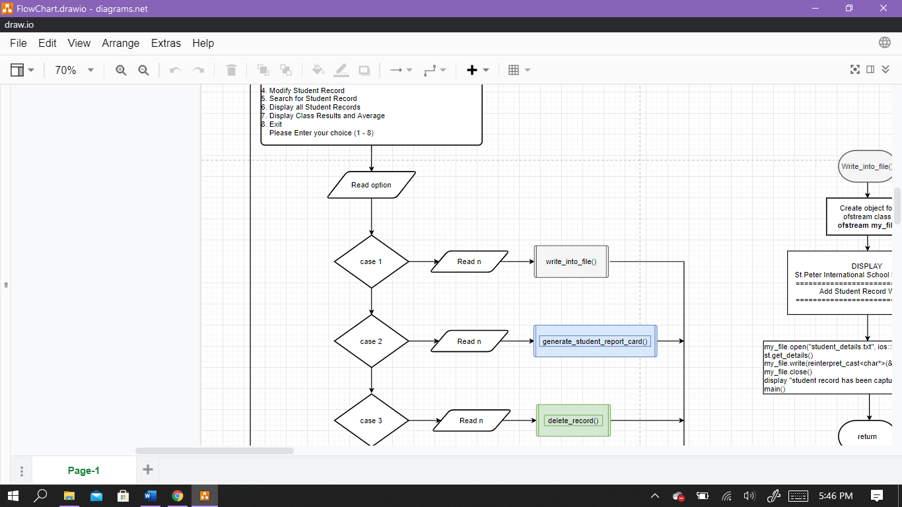

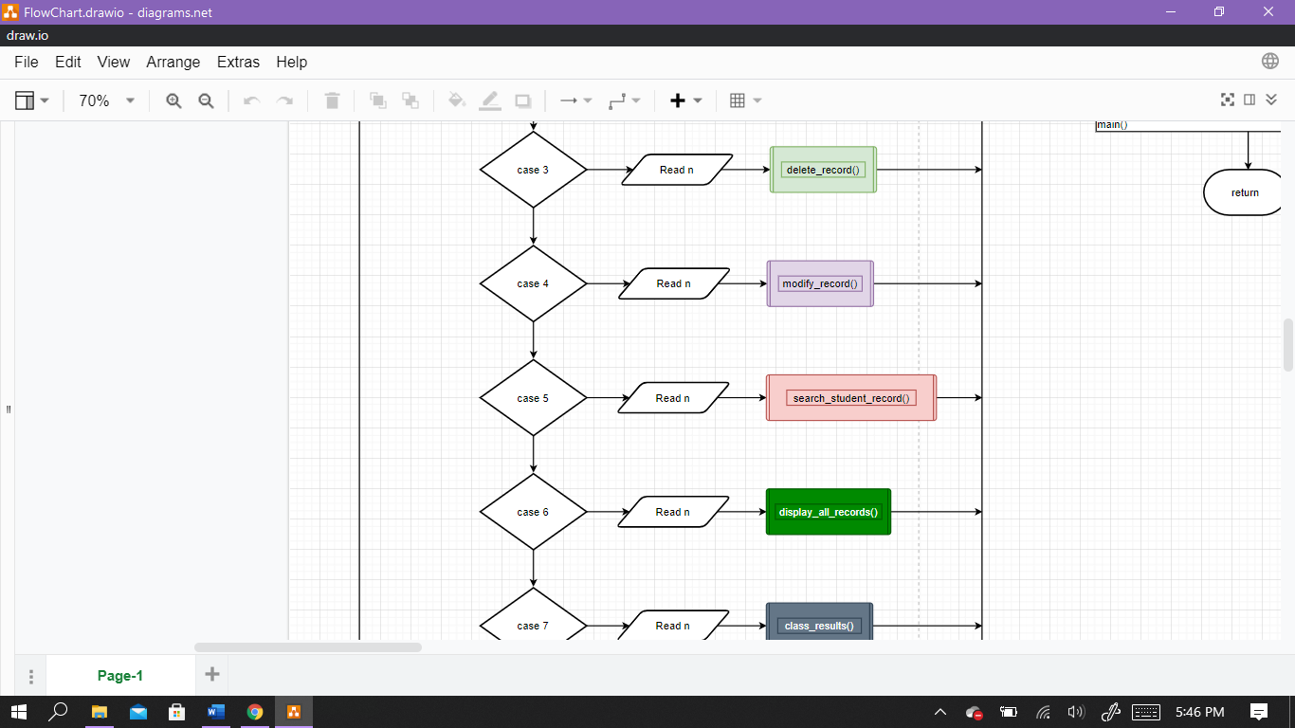

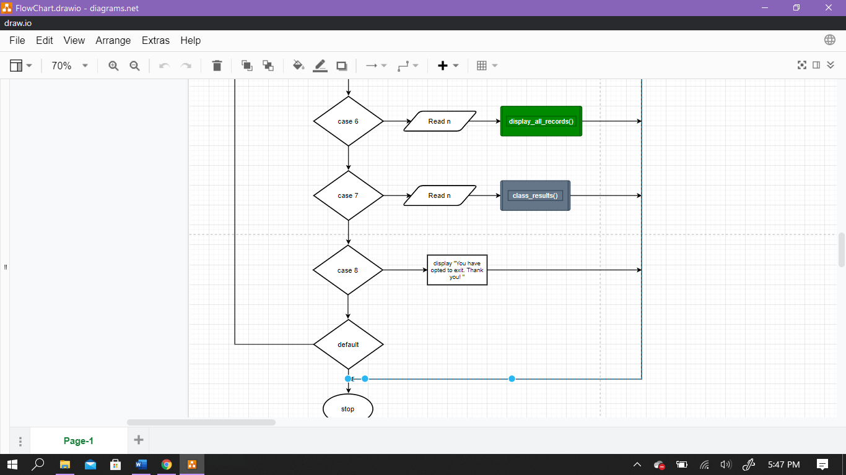

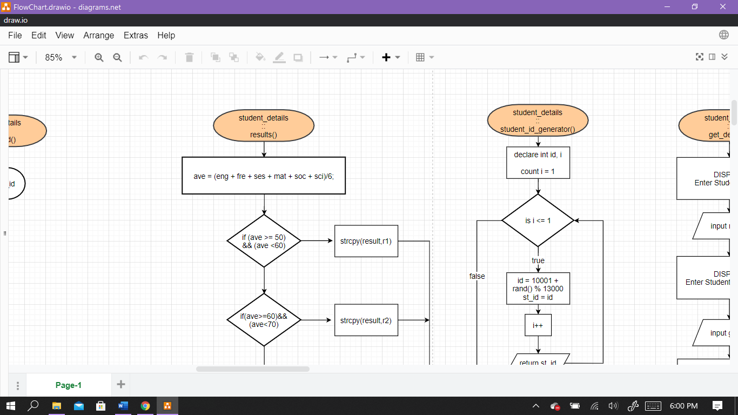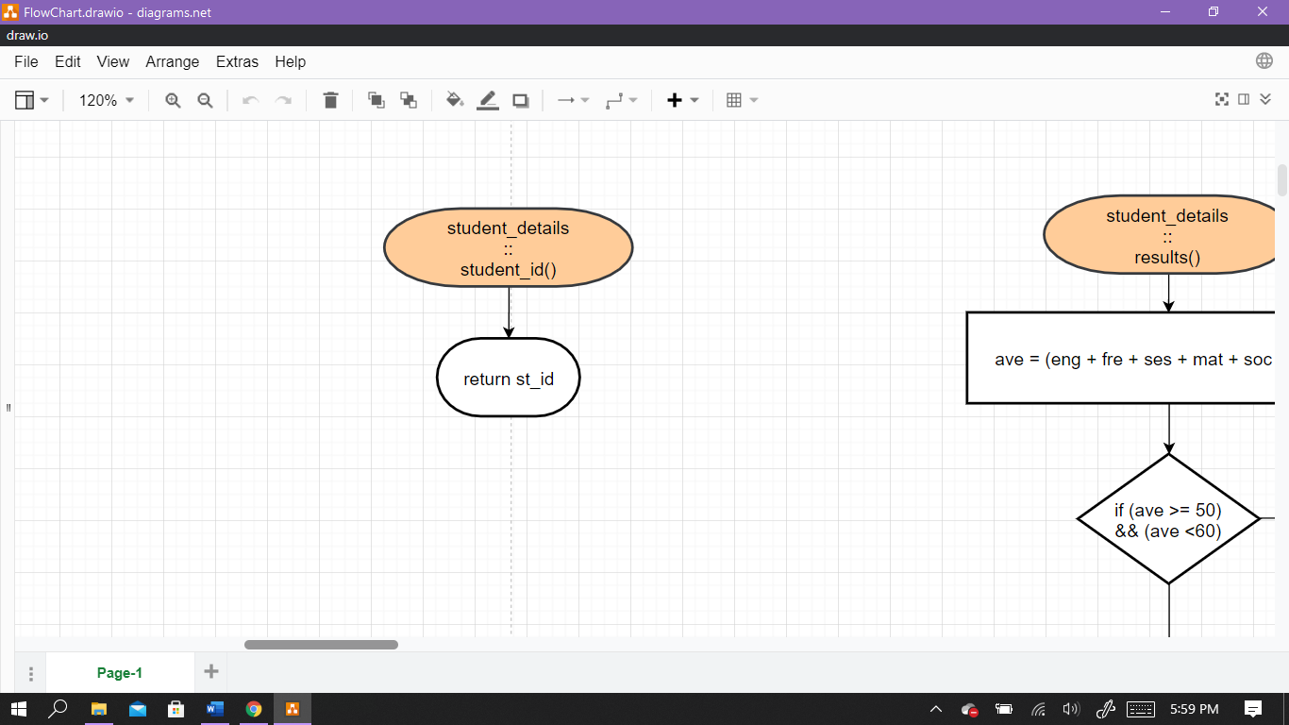

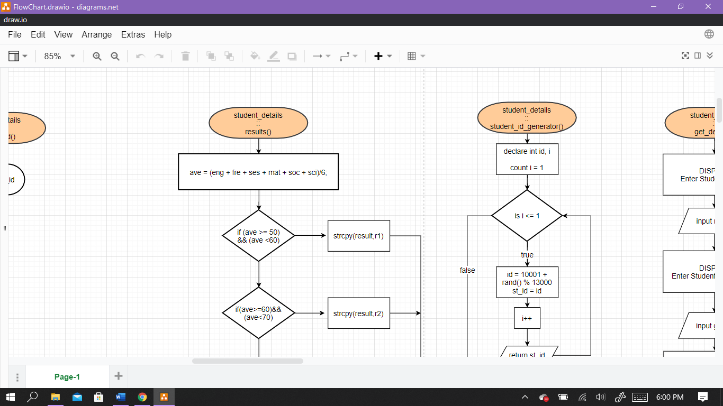

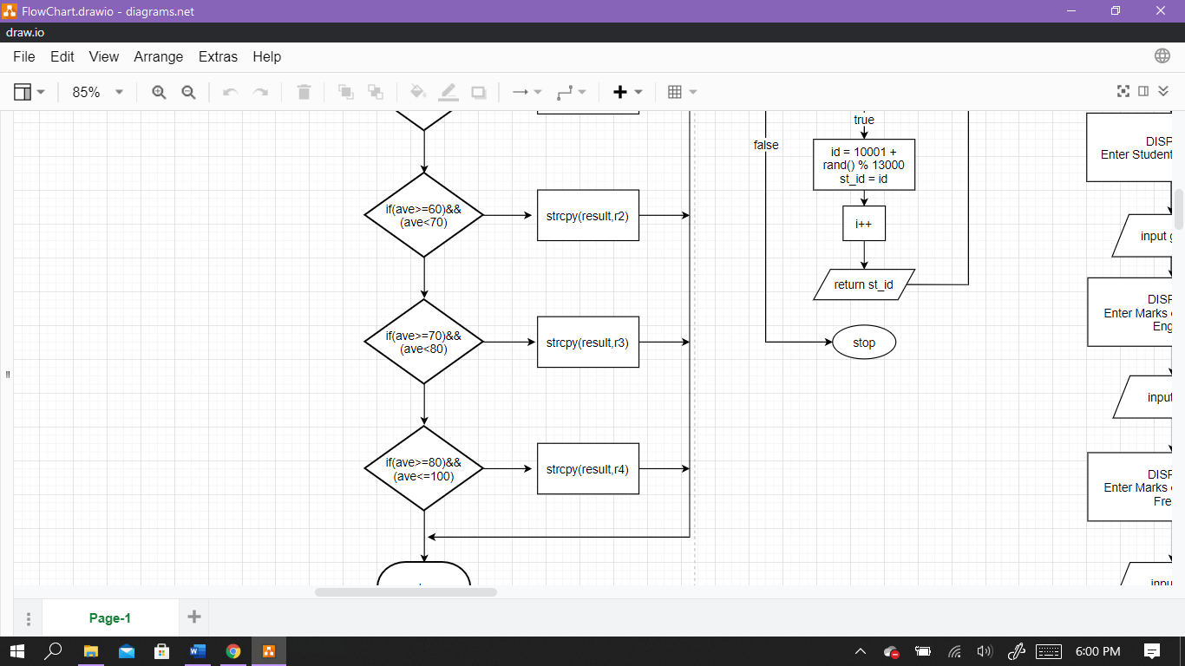



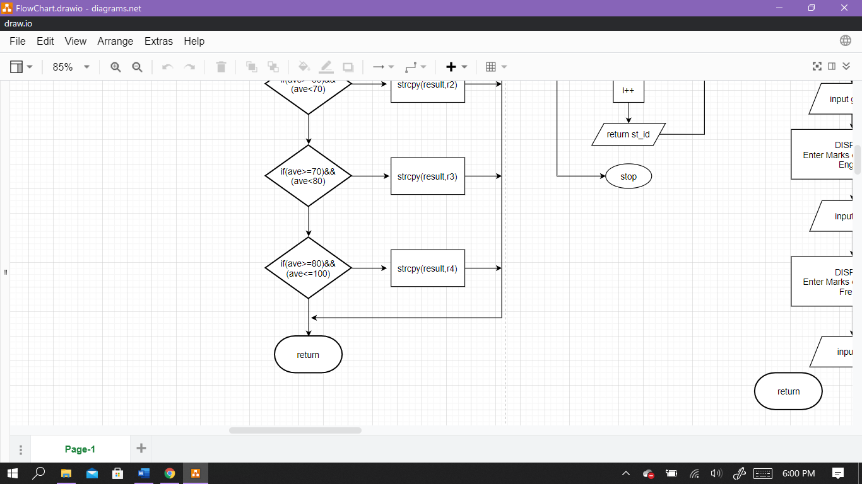

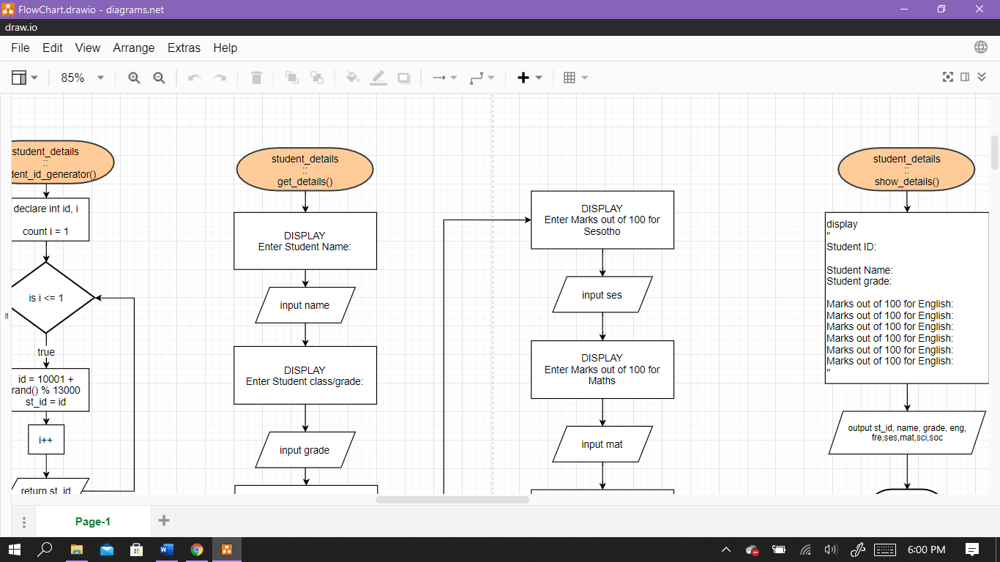

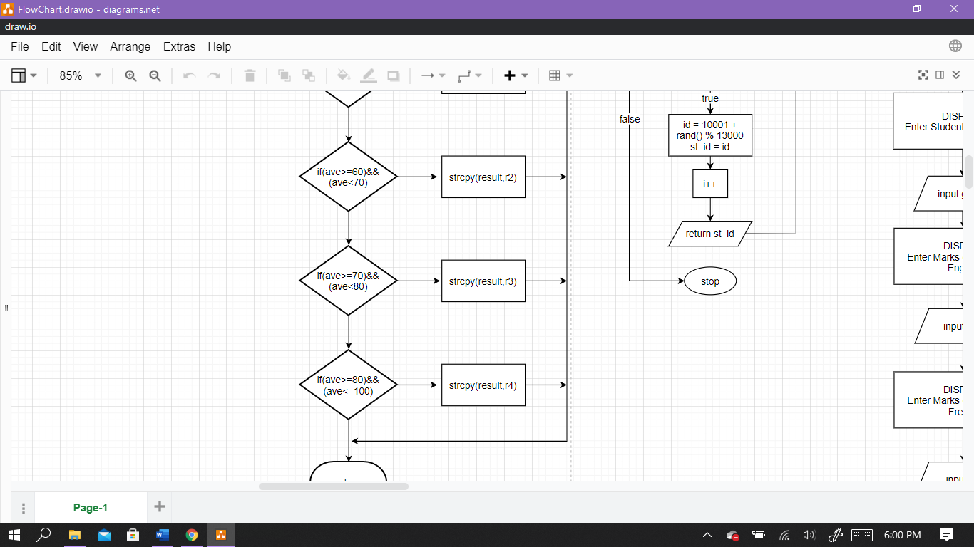

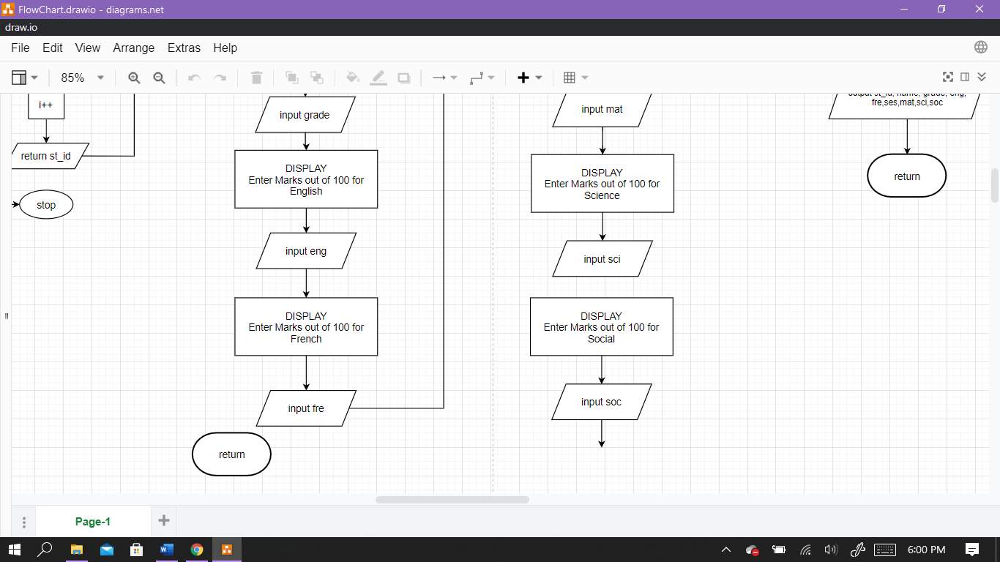

3

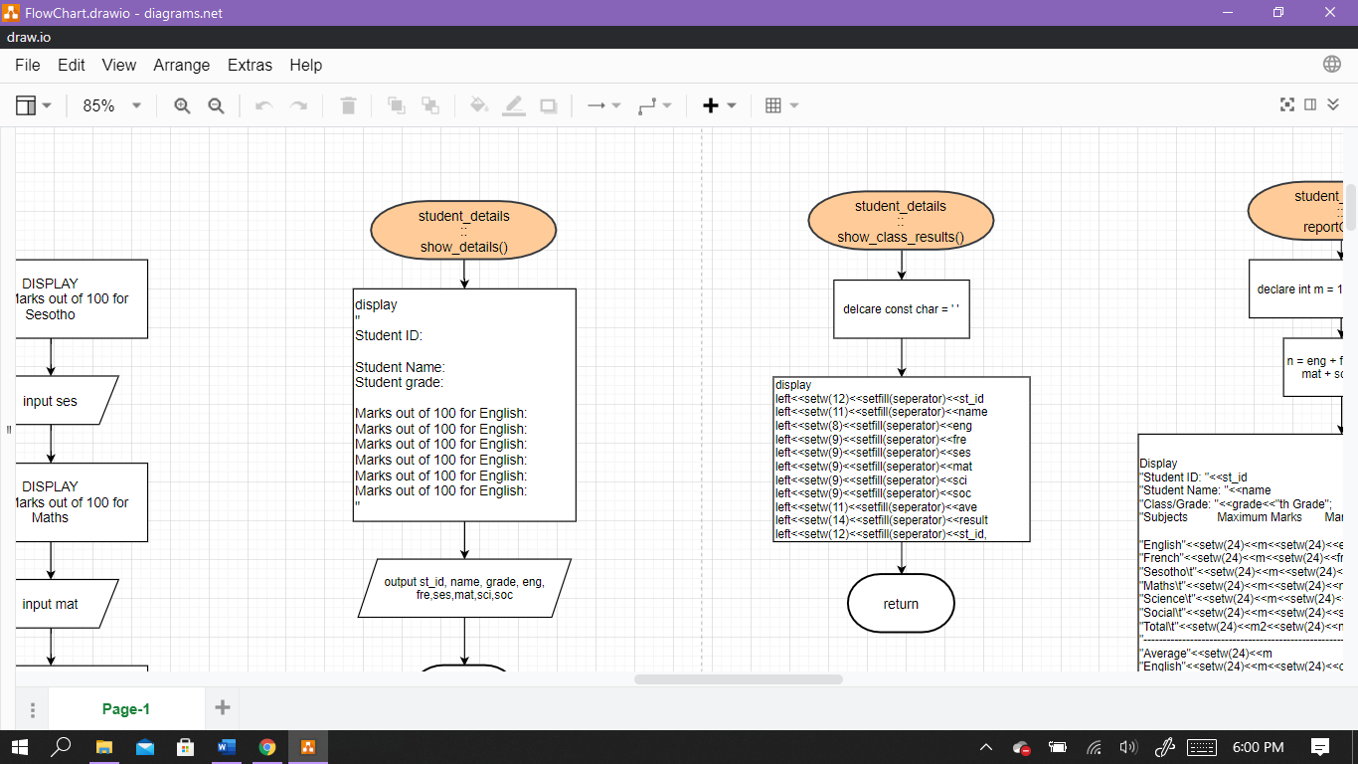

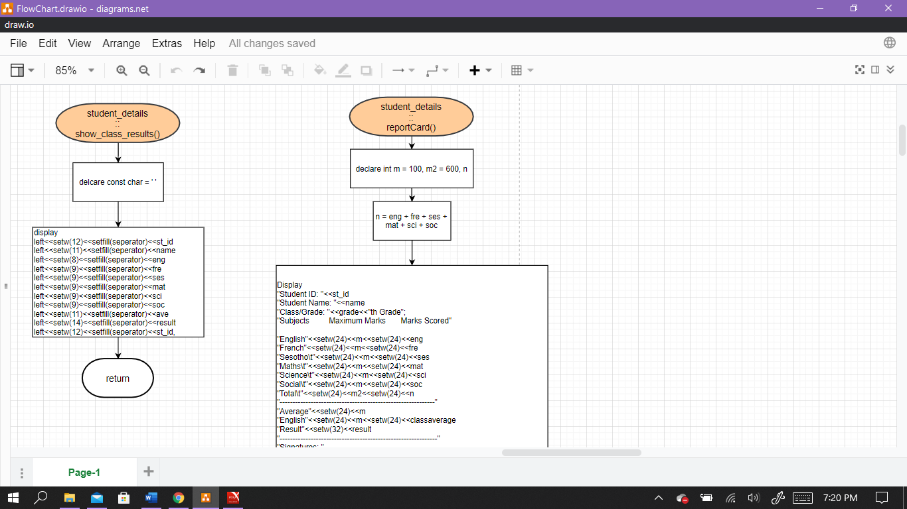





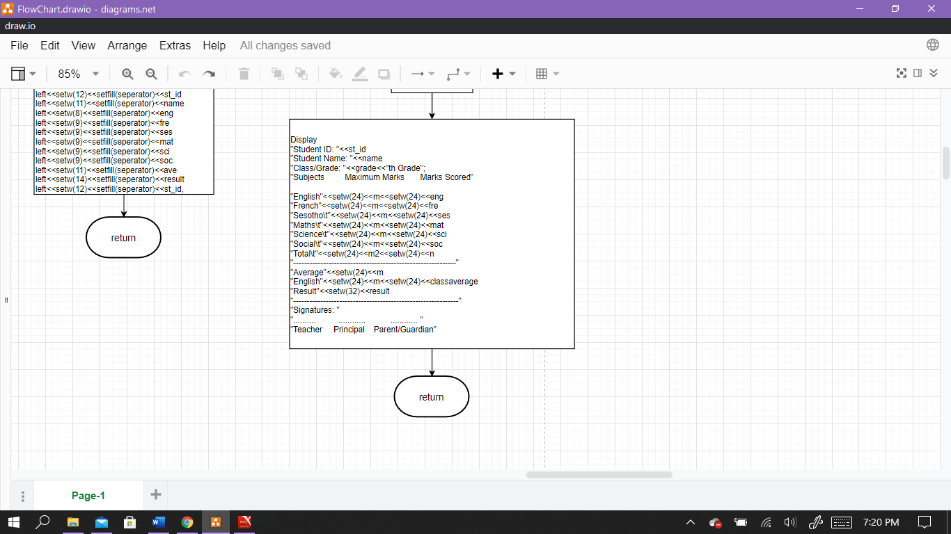

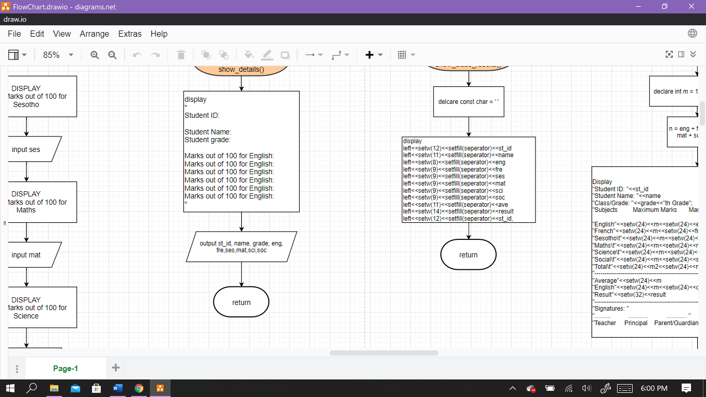

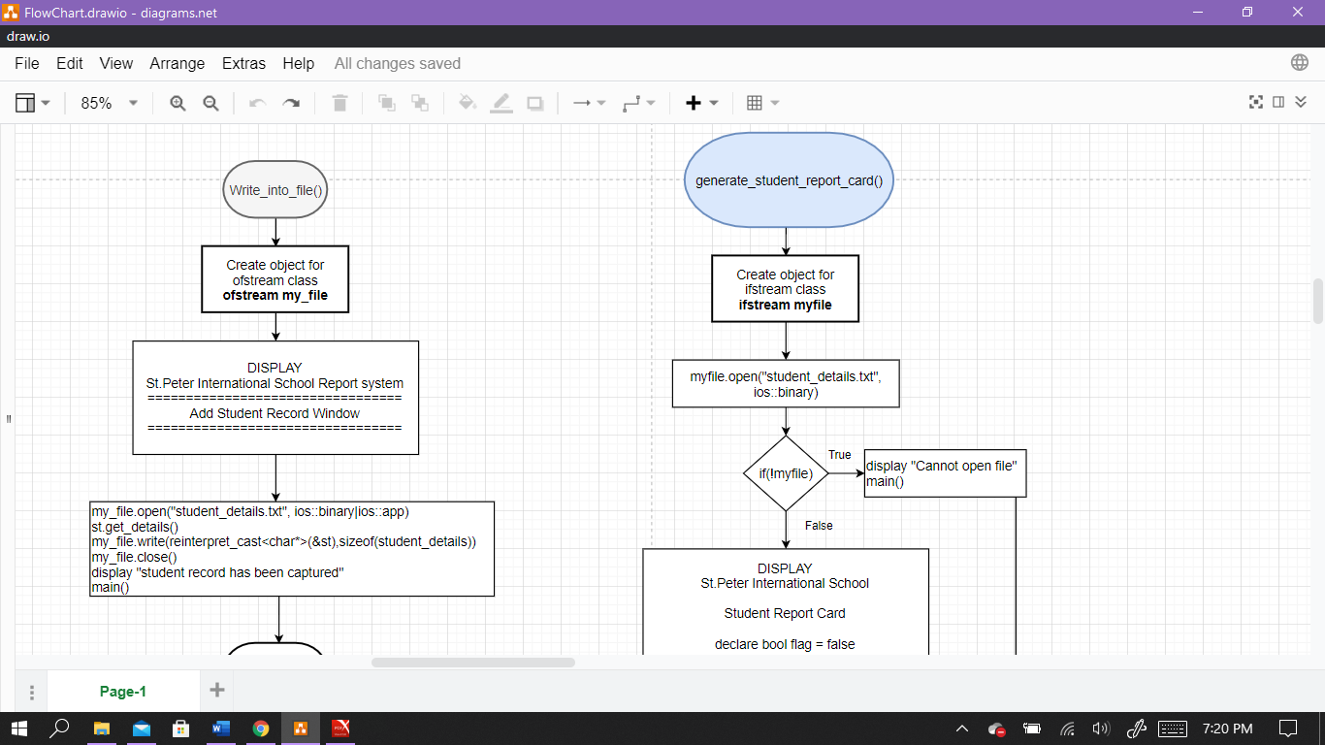

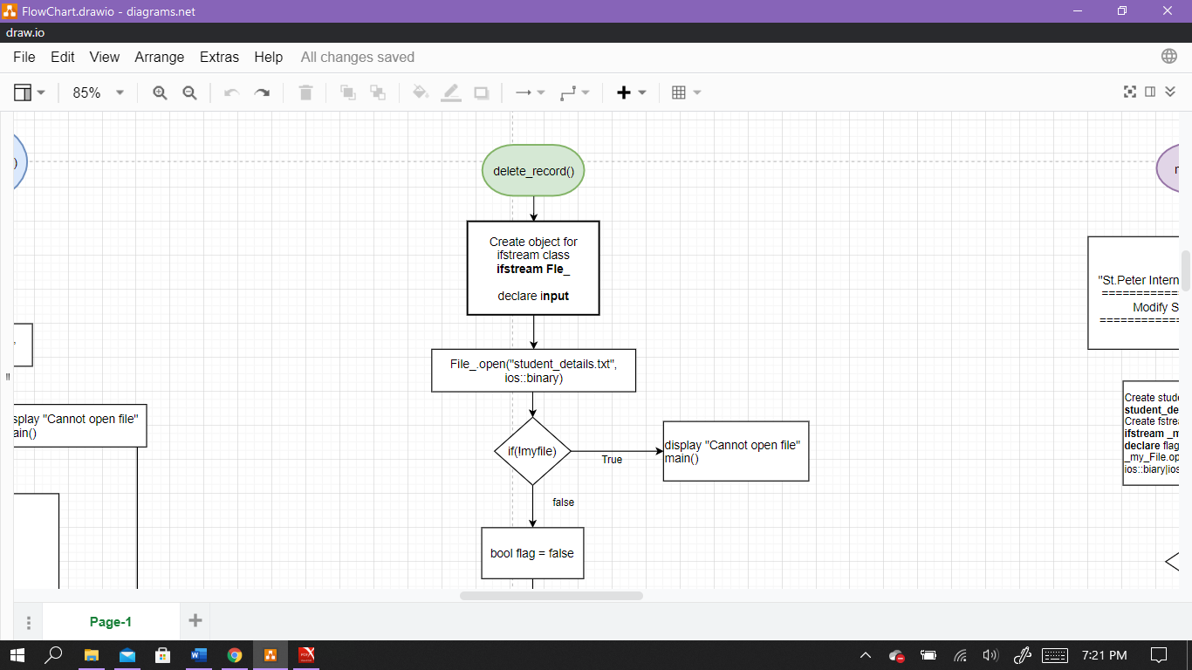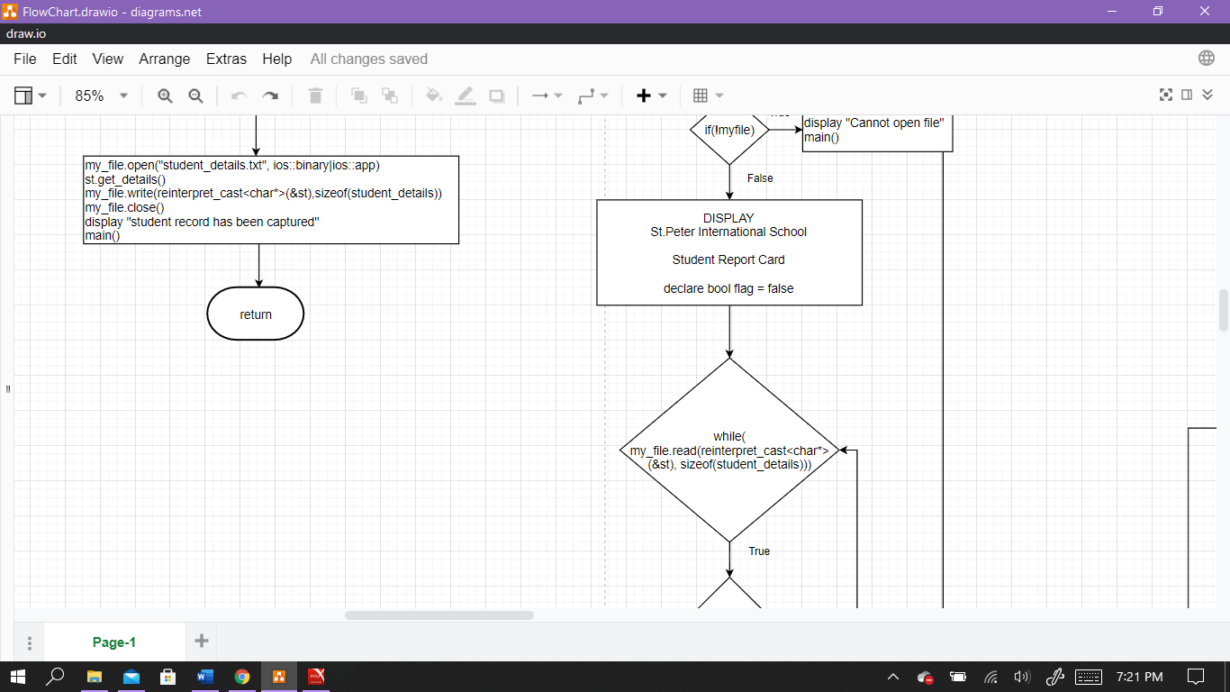

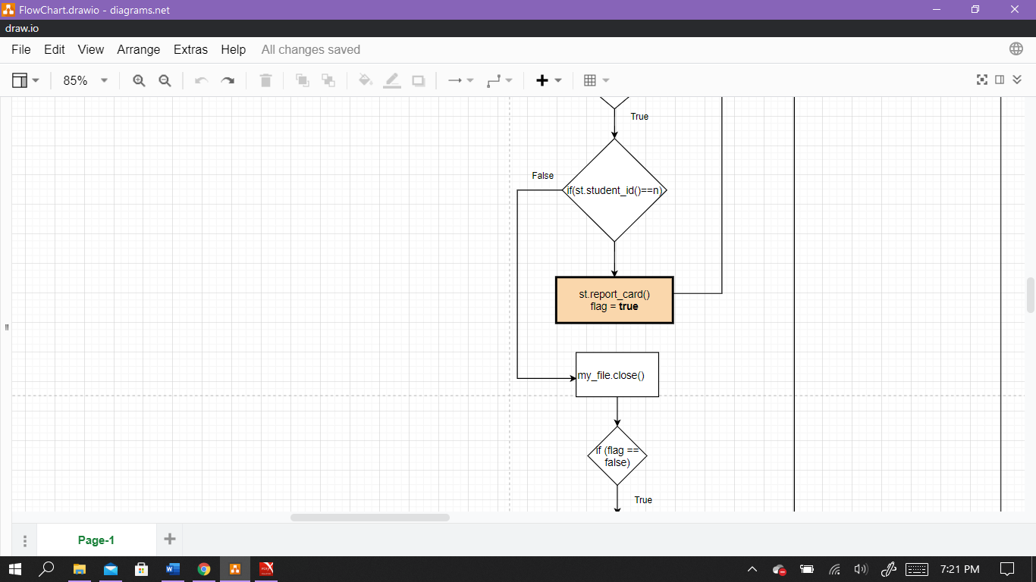

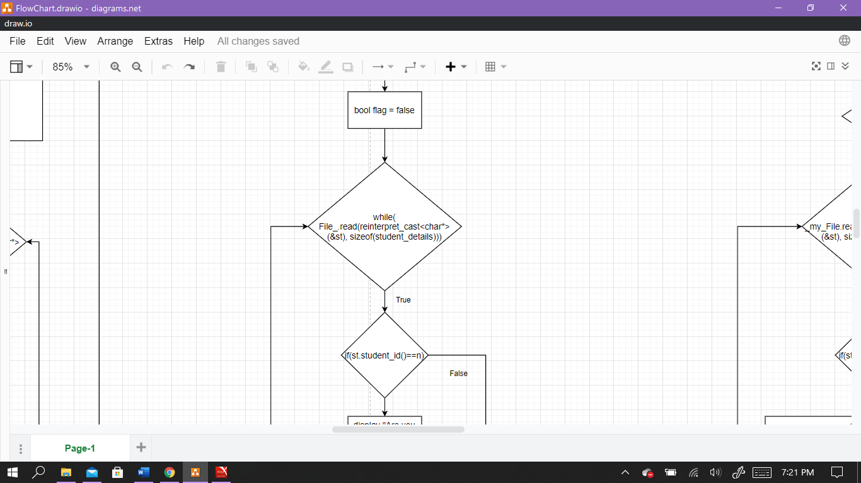

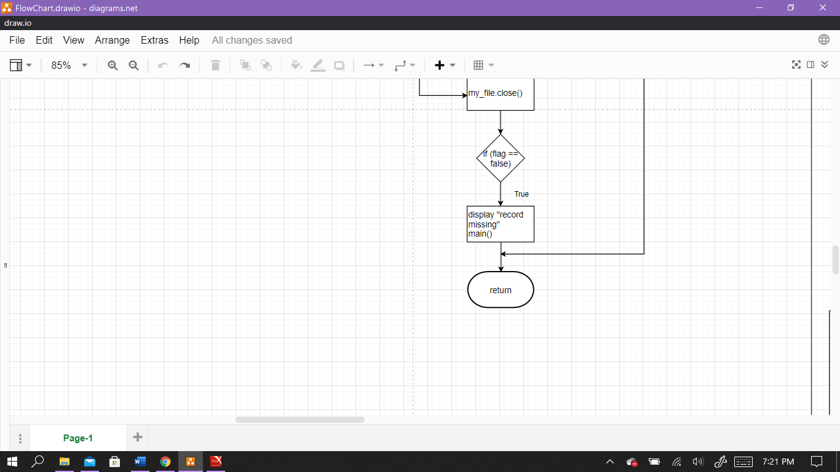

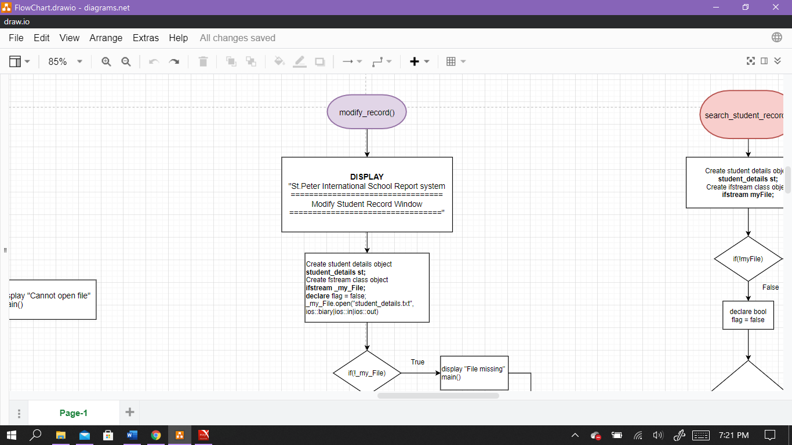

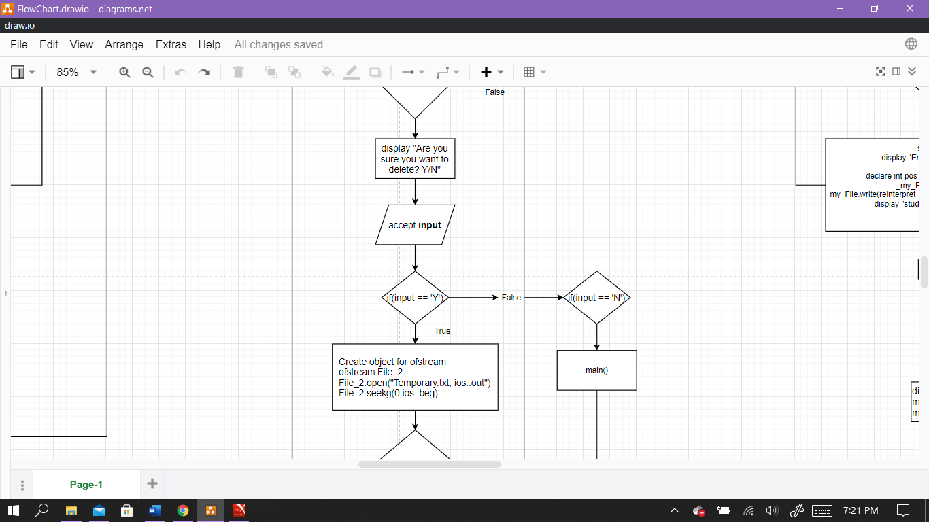

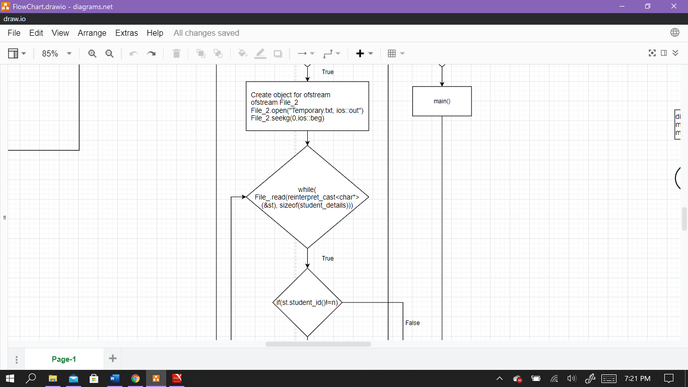

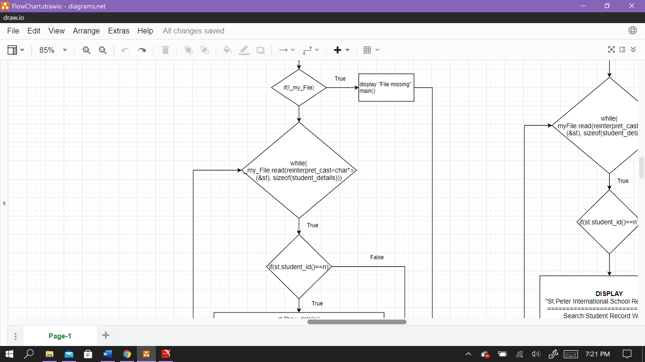

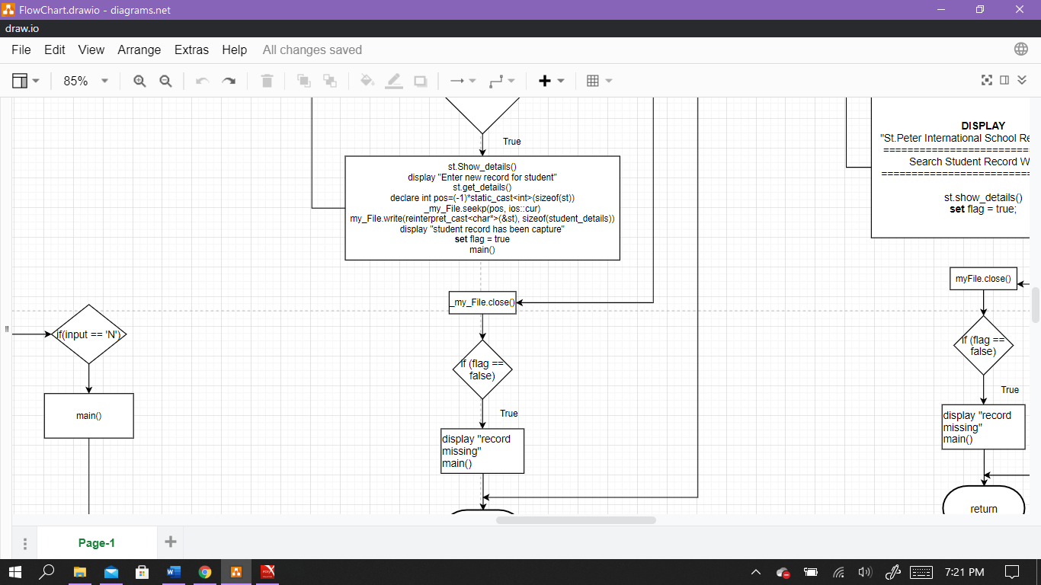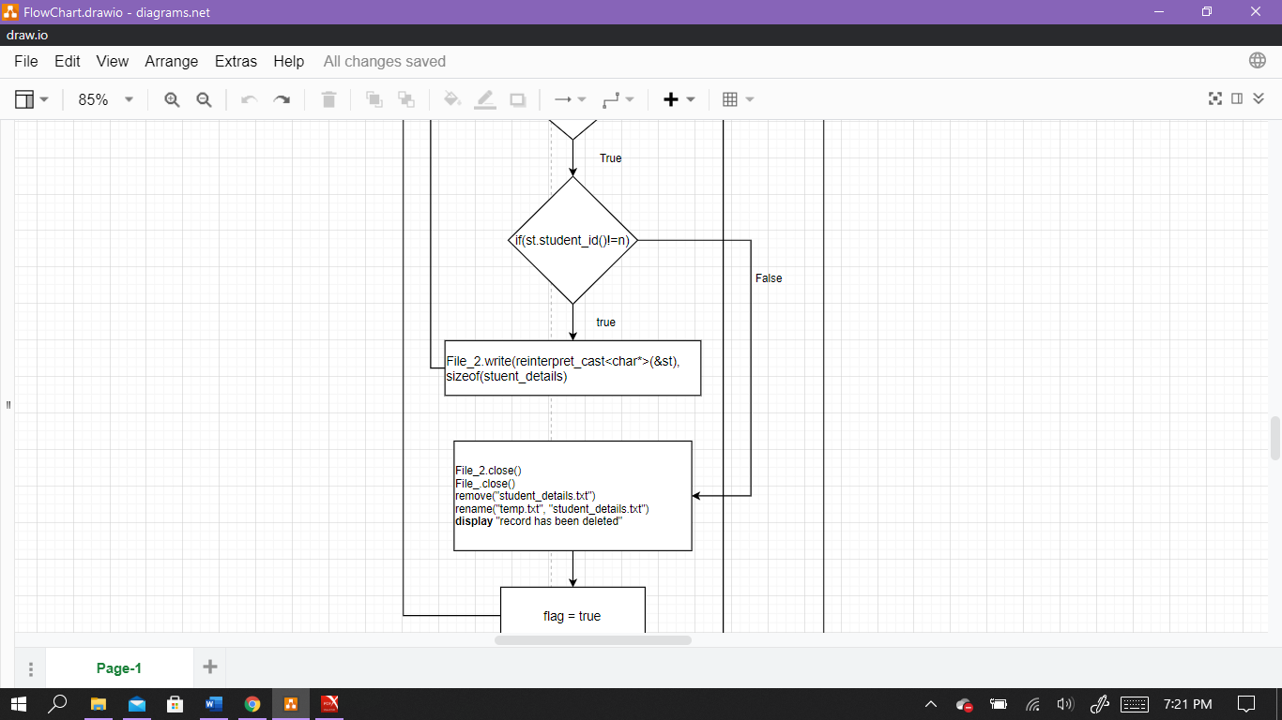

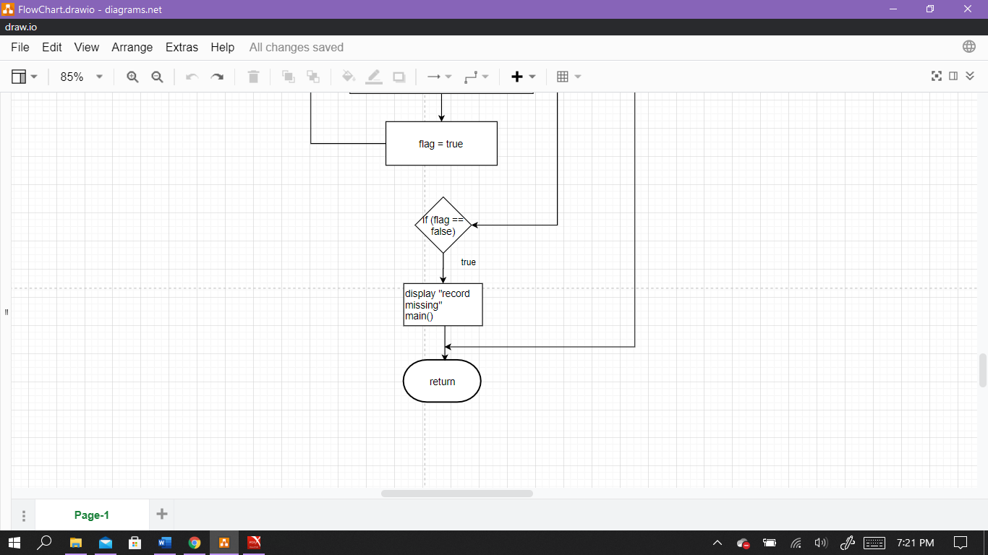

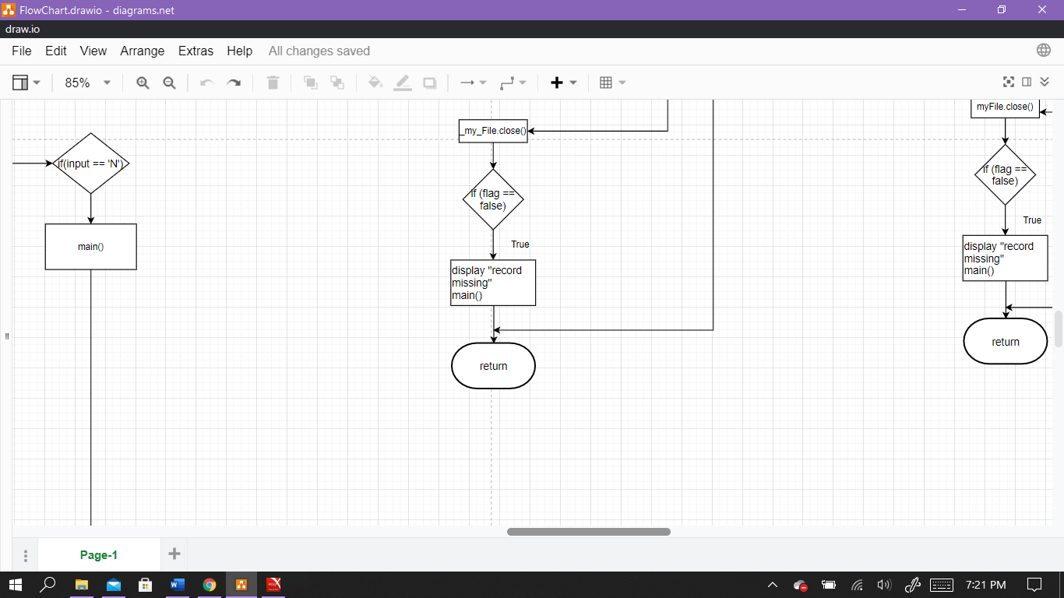

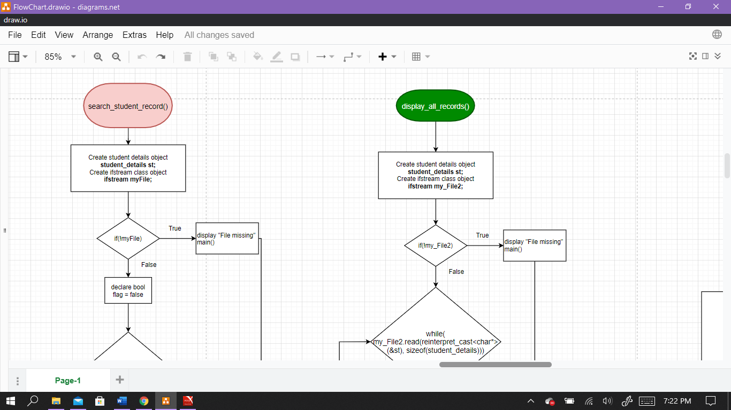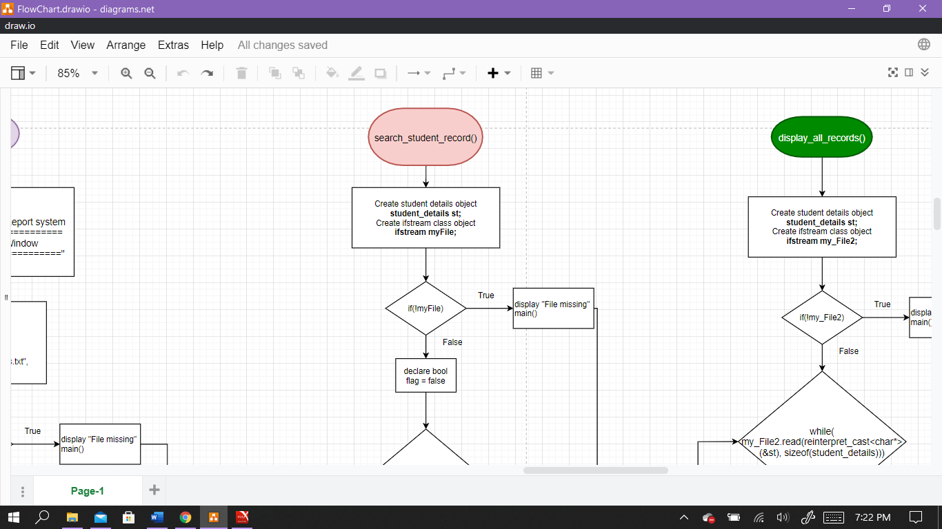

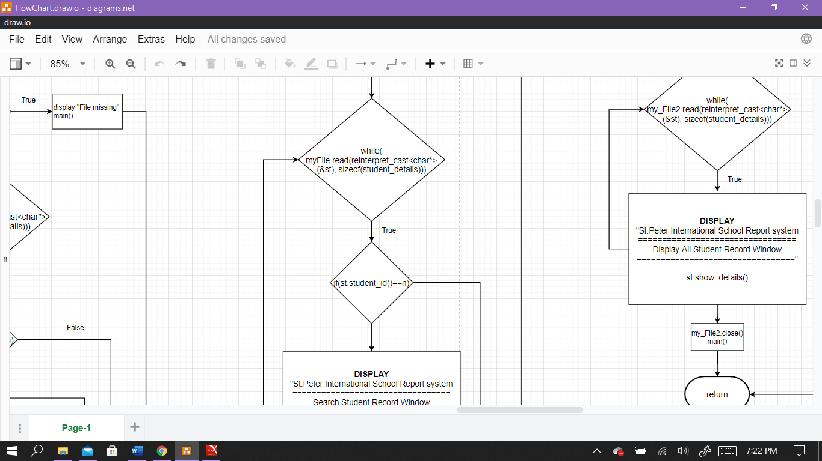

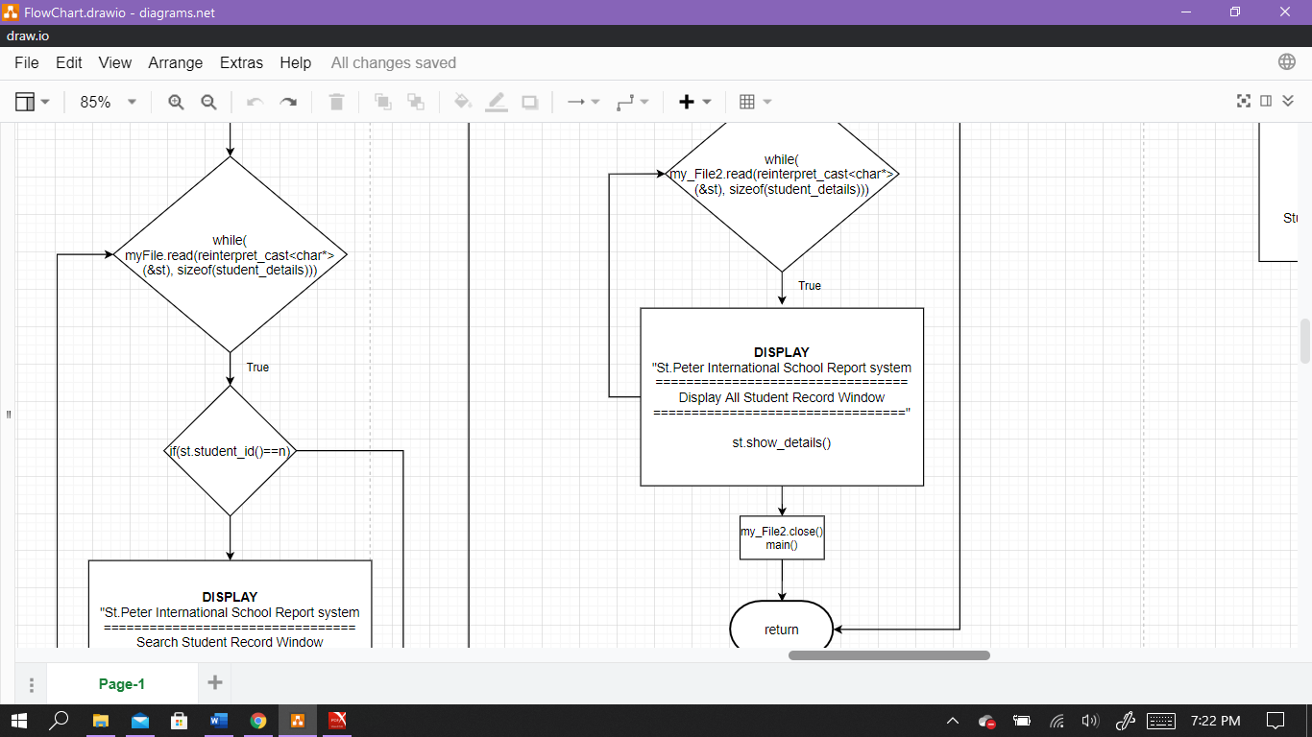

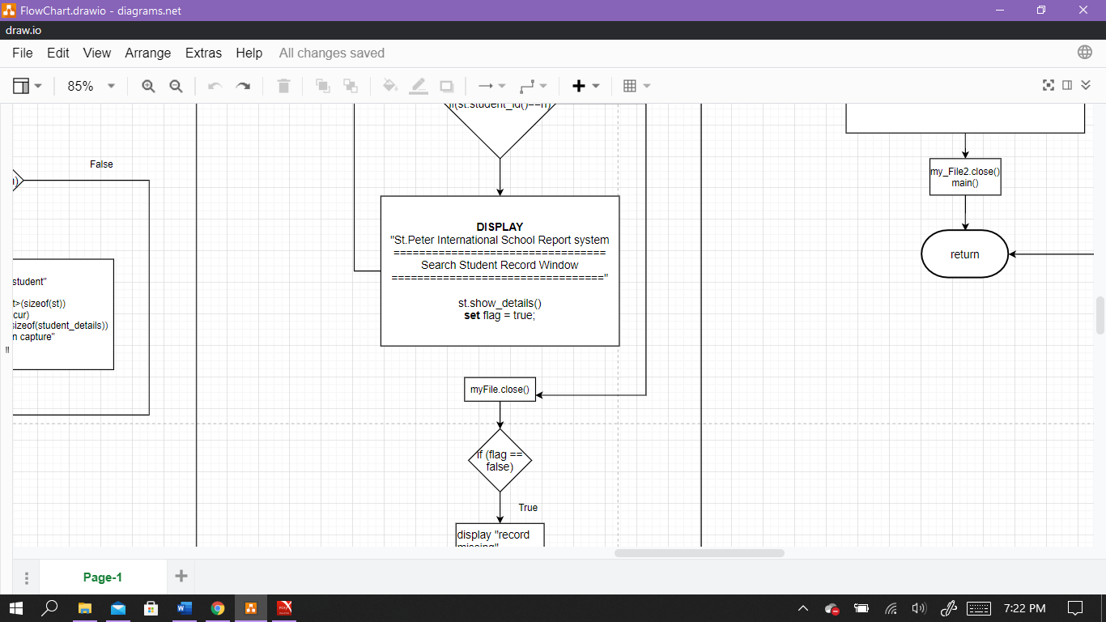

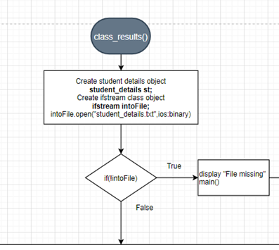

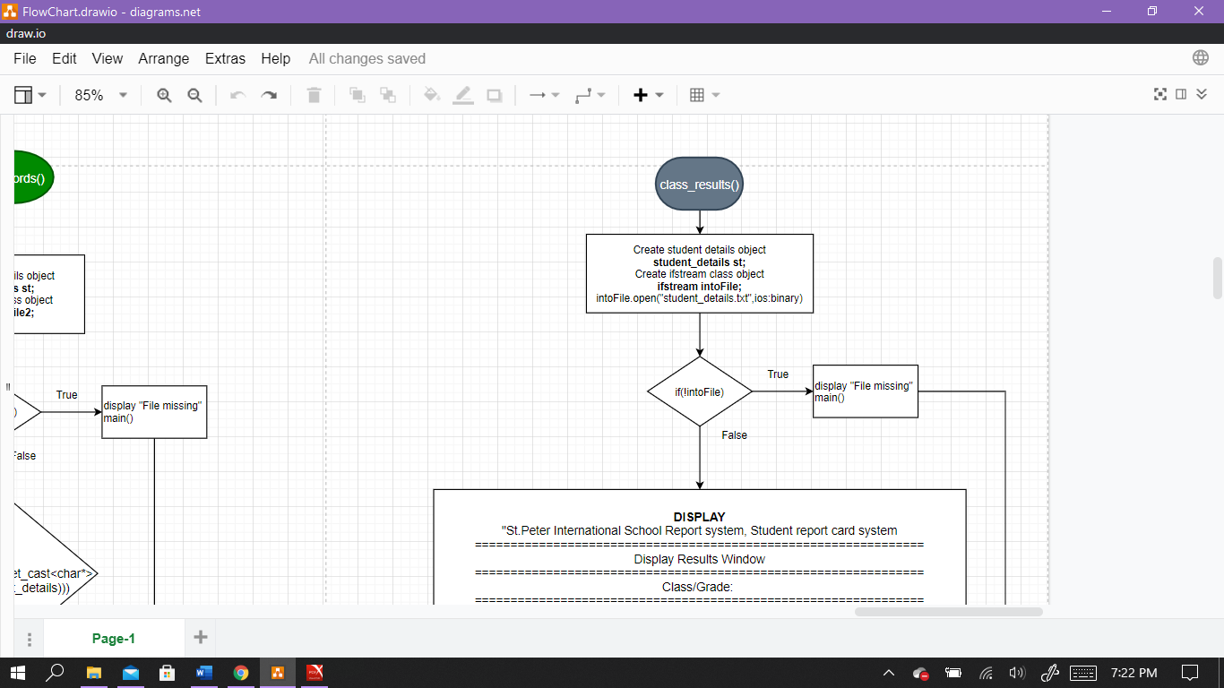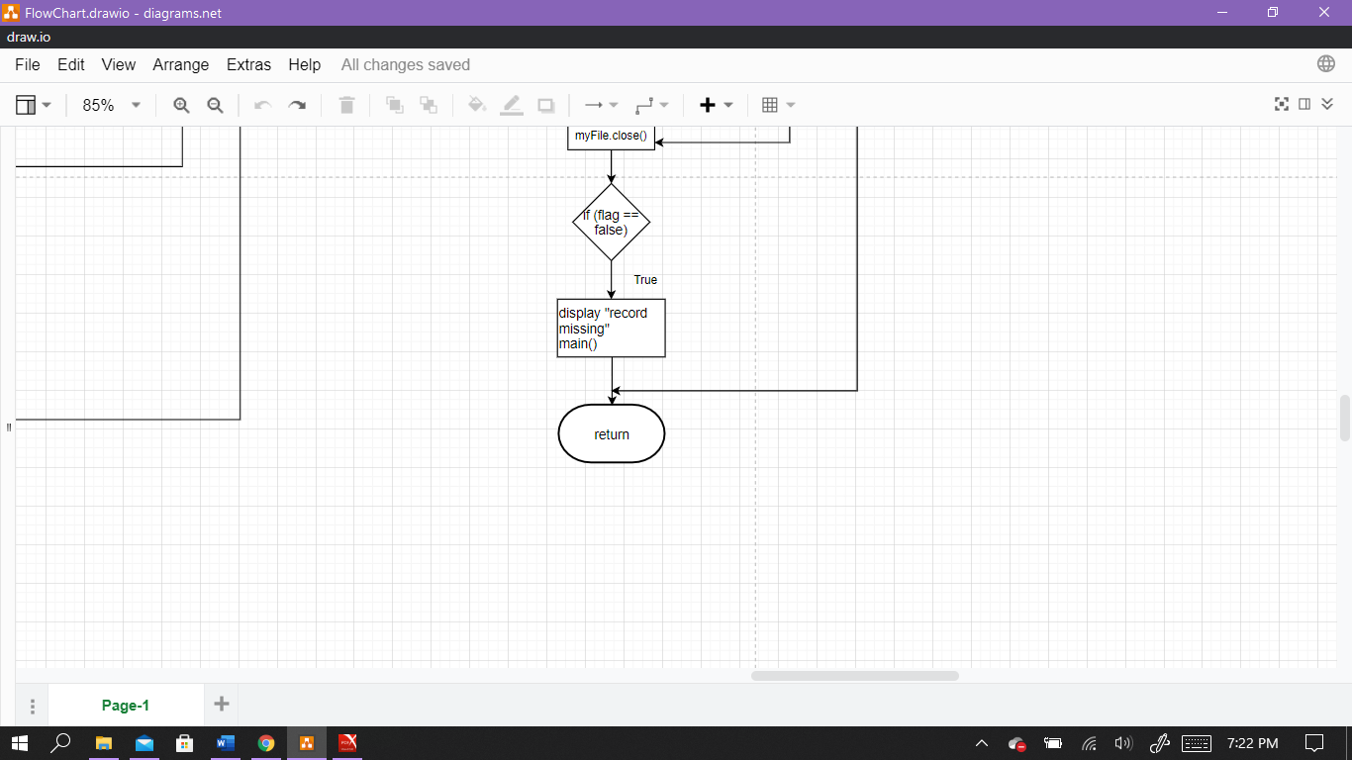

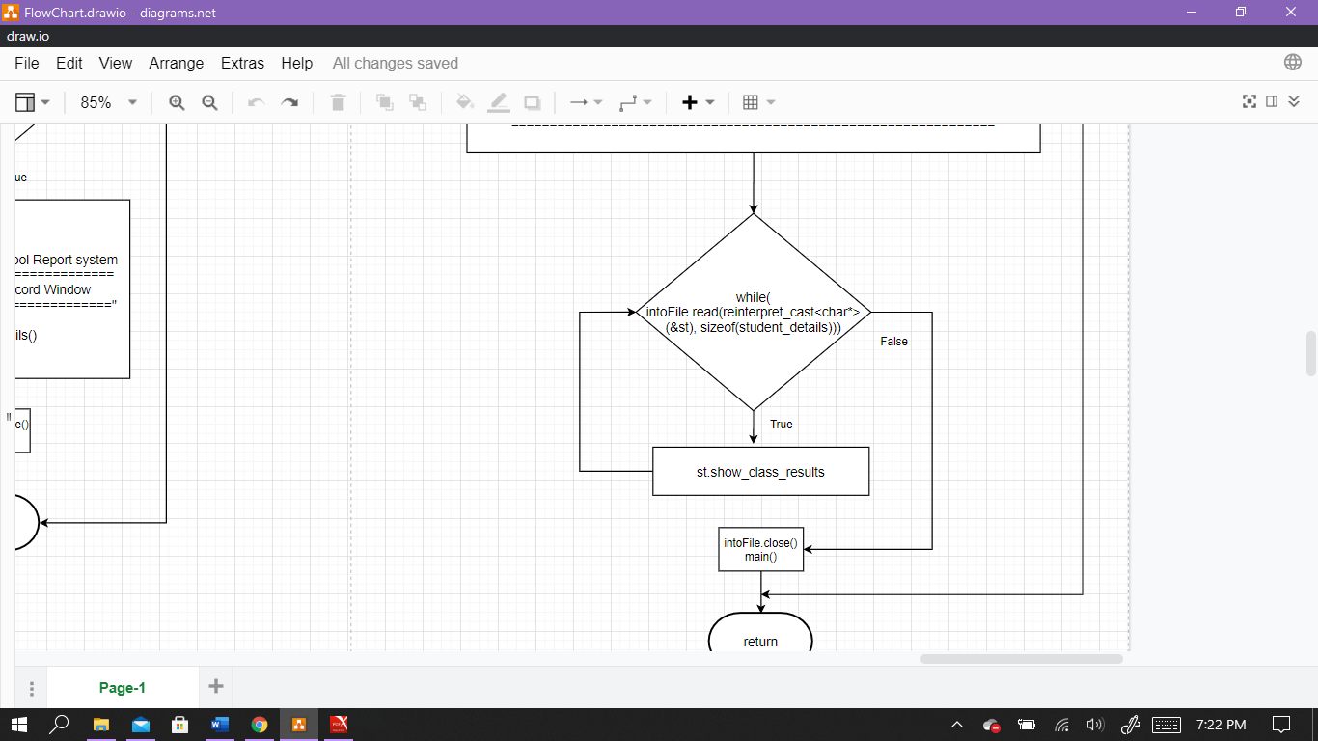

**4. Implementation**

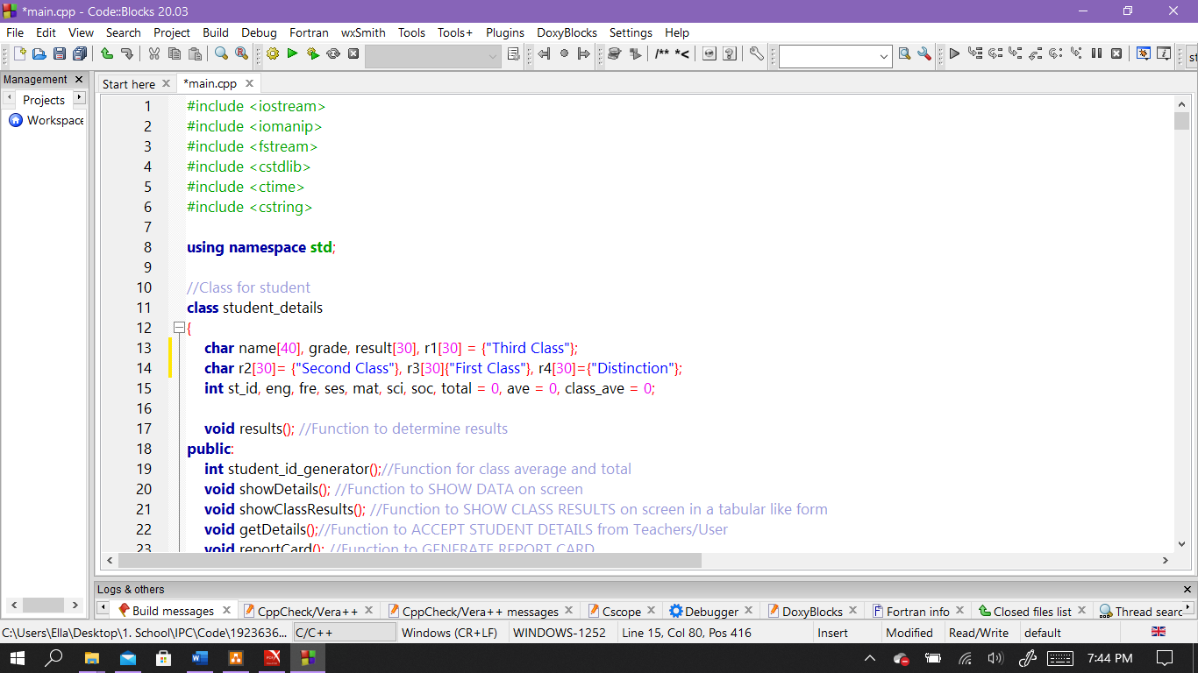**Program Code**

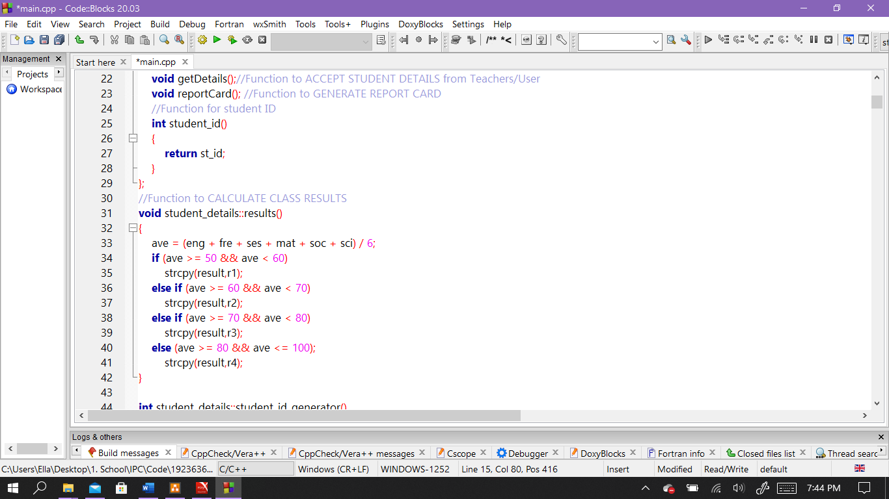

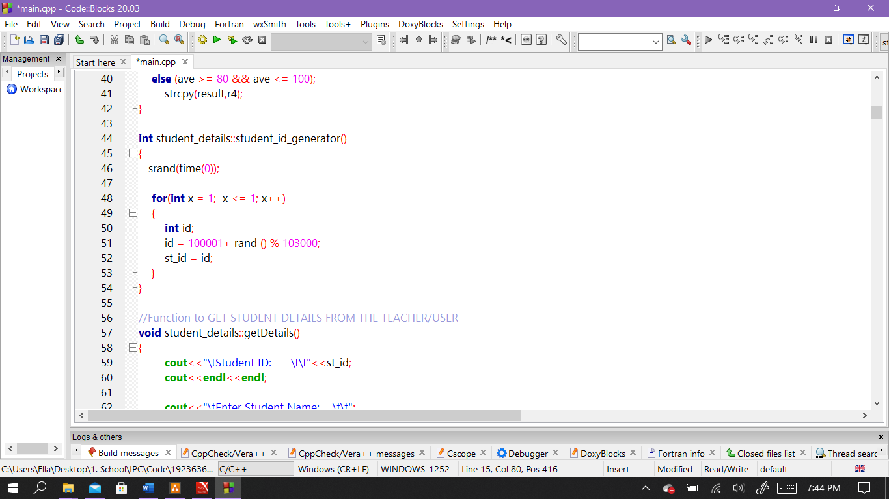

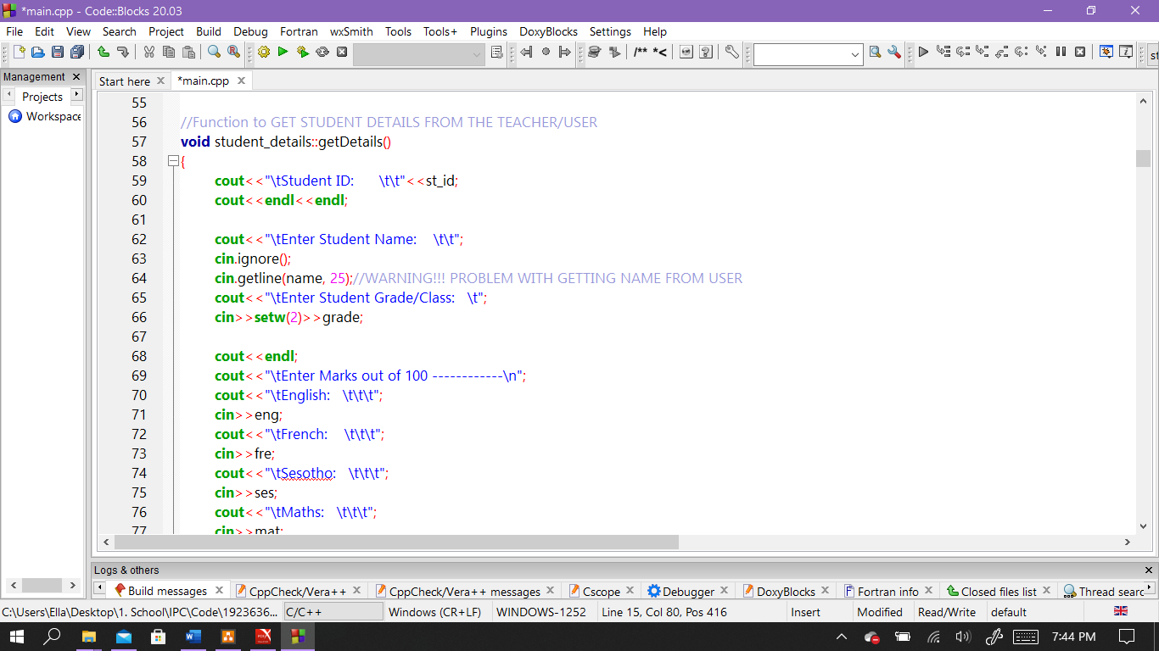

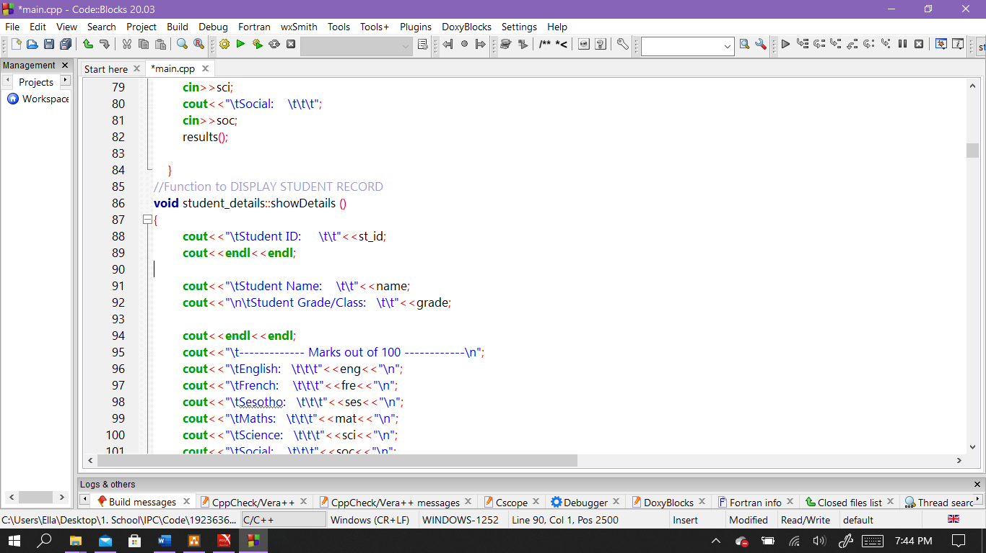

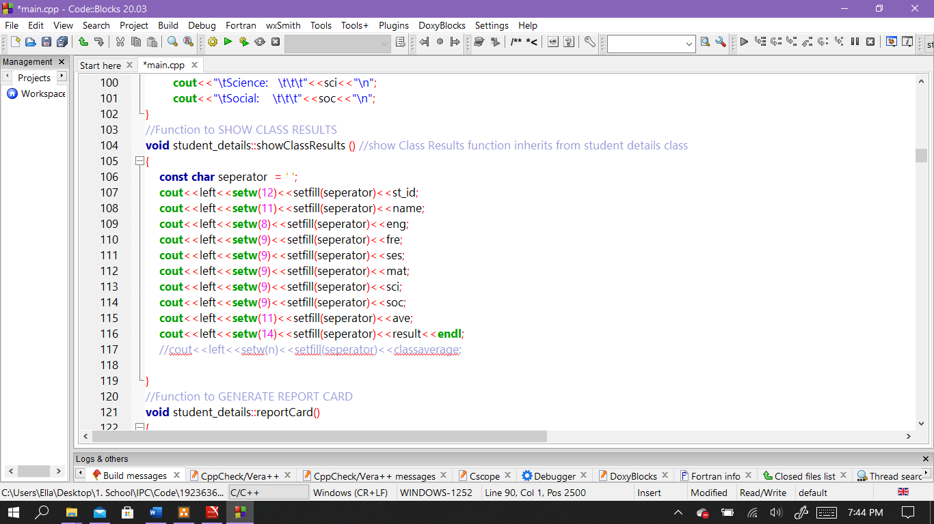

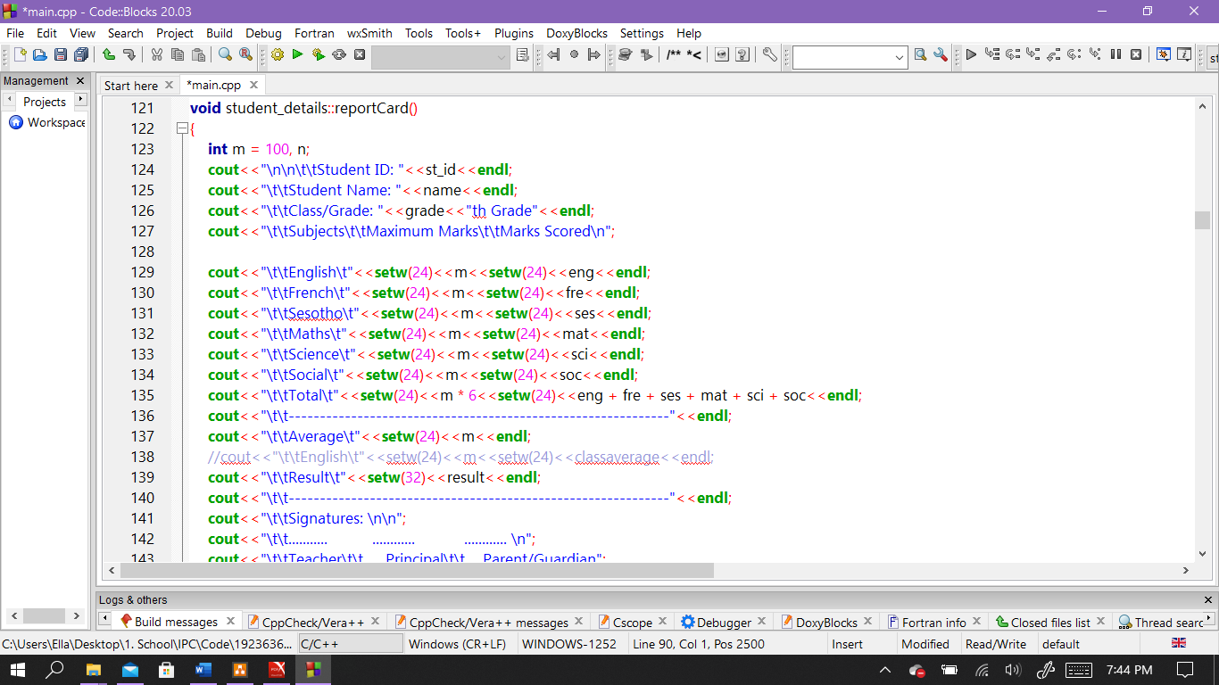

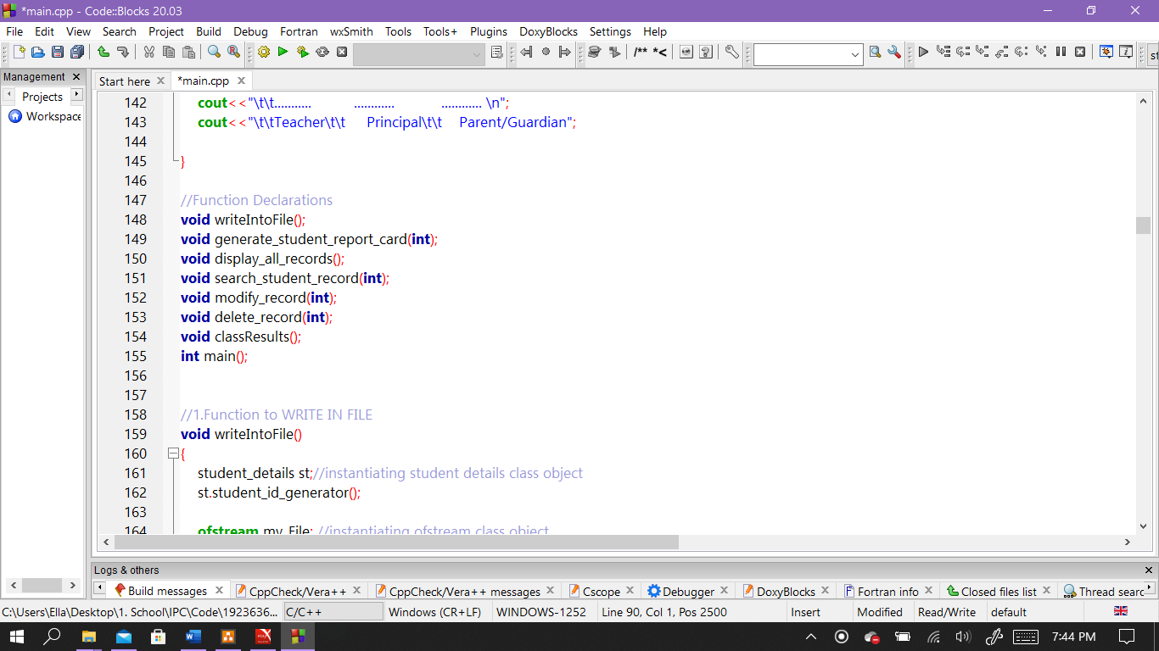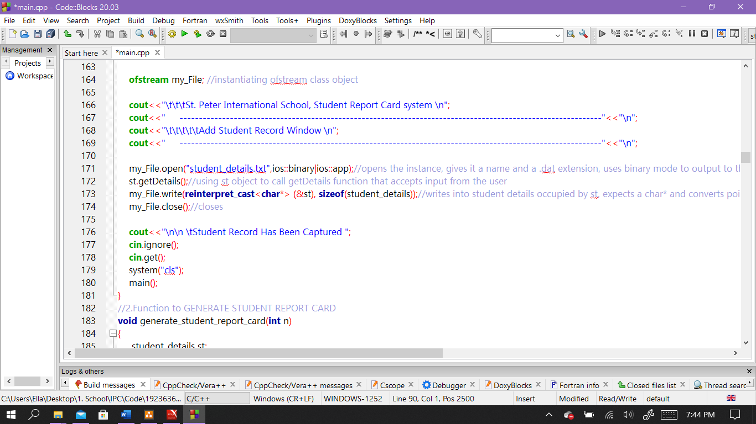

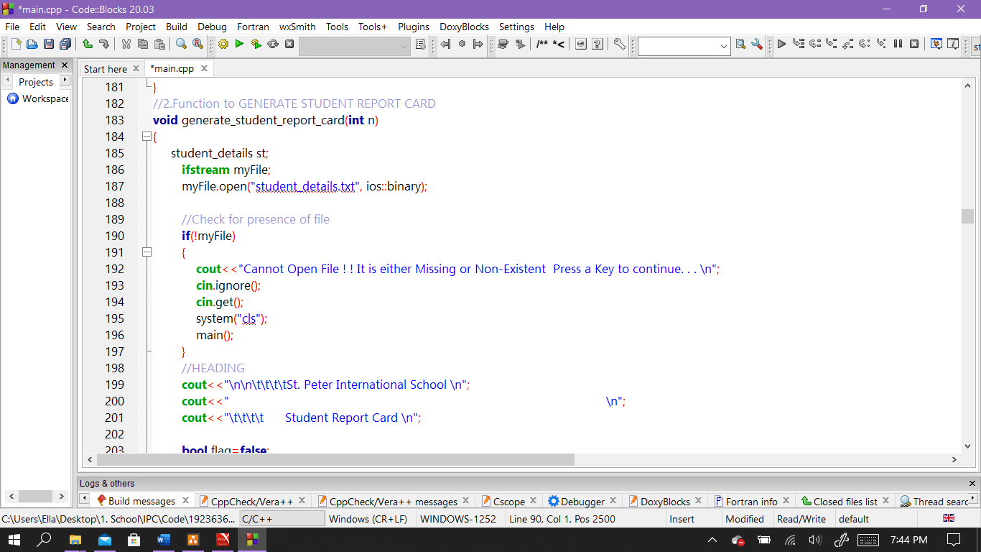

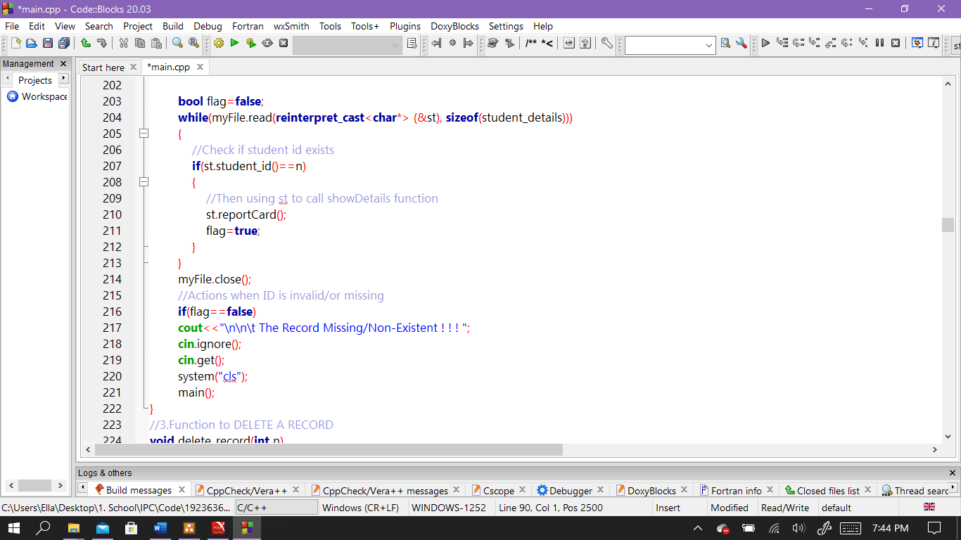

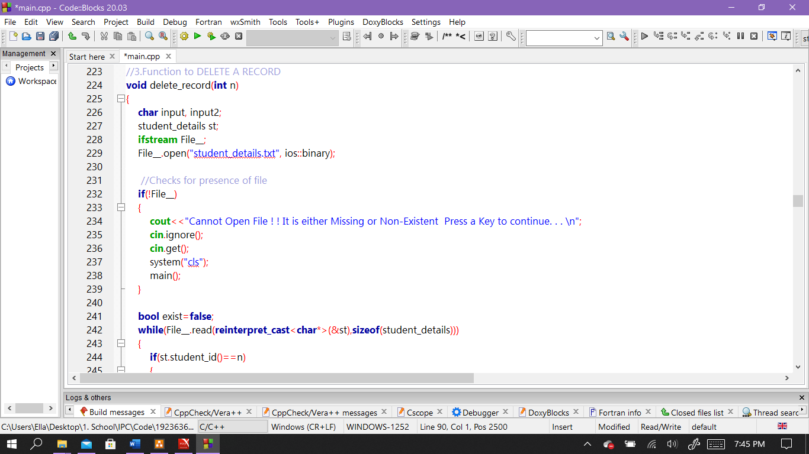

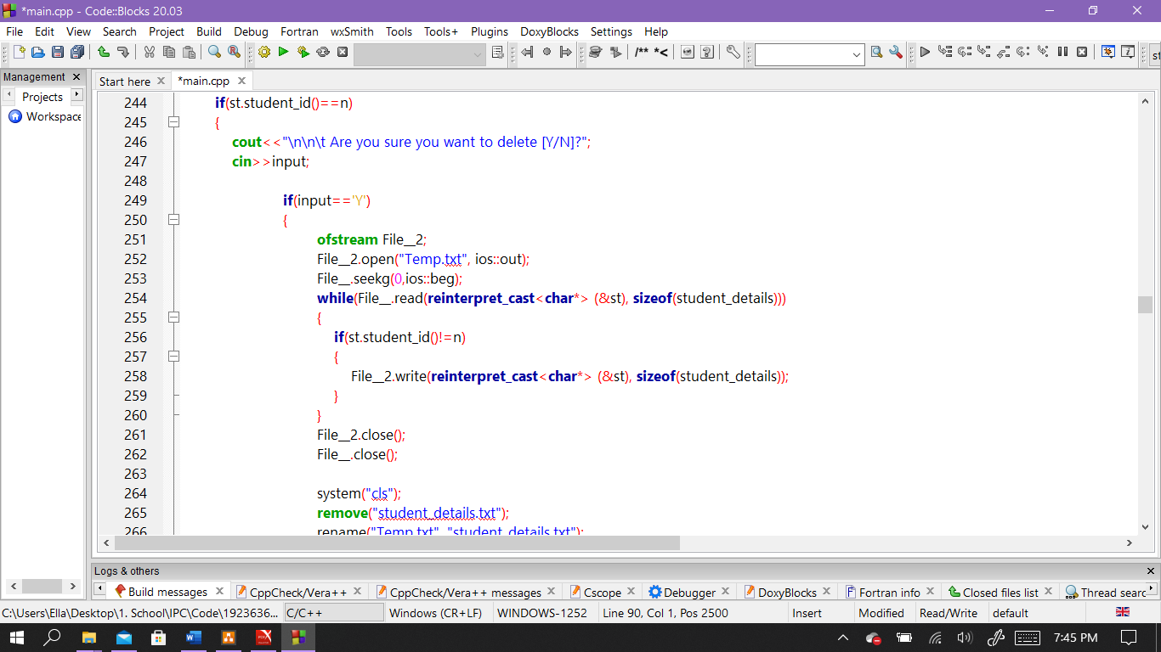

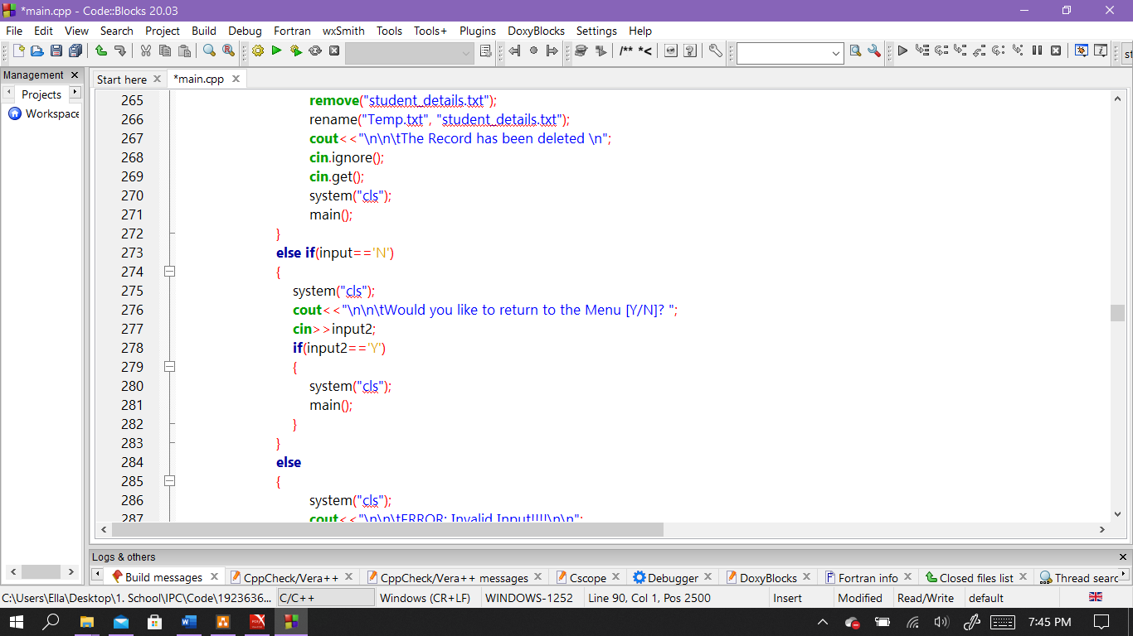

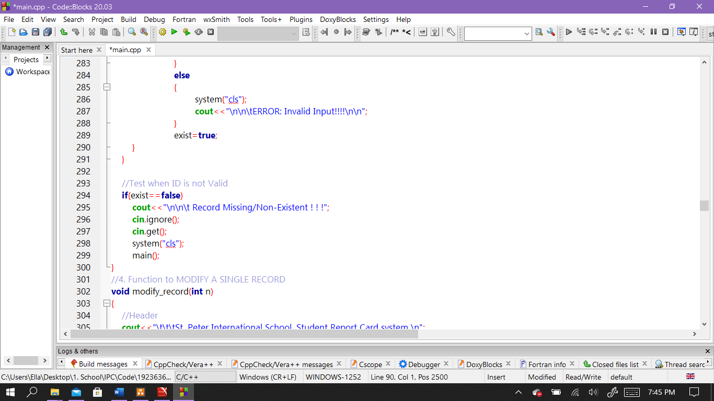

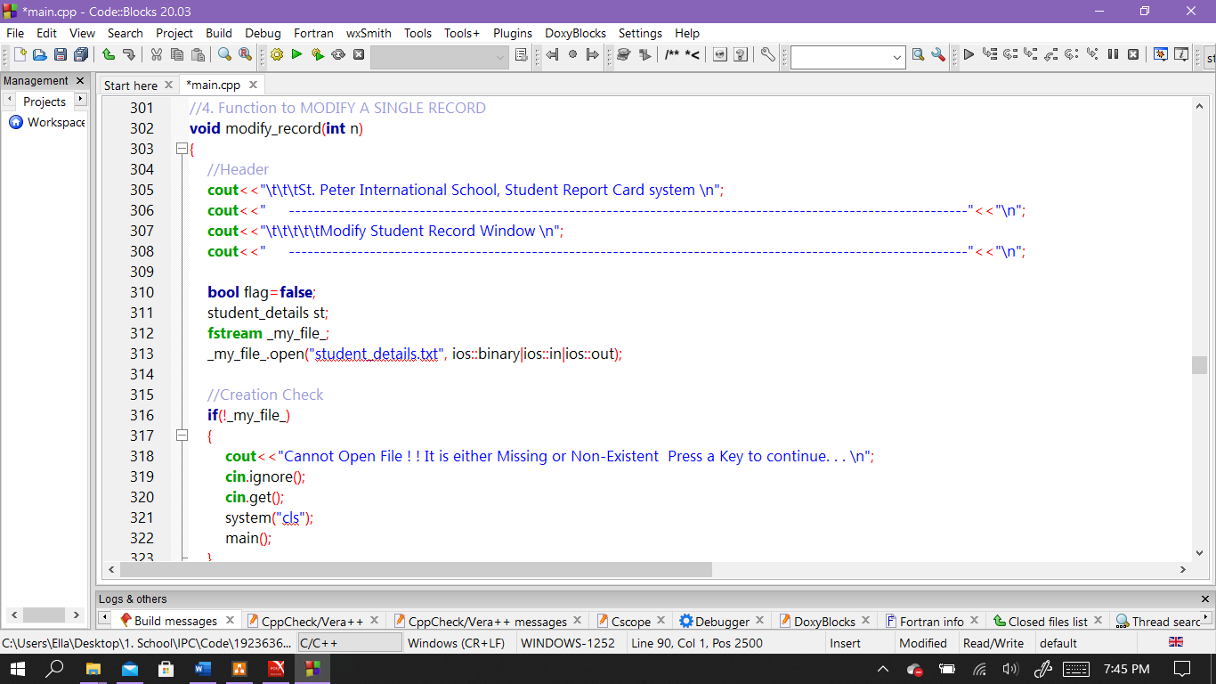

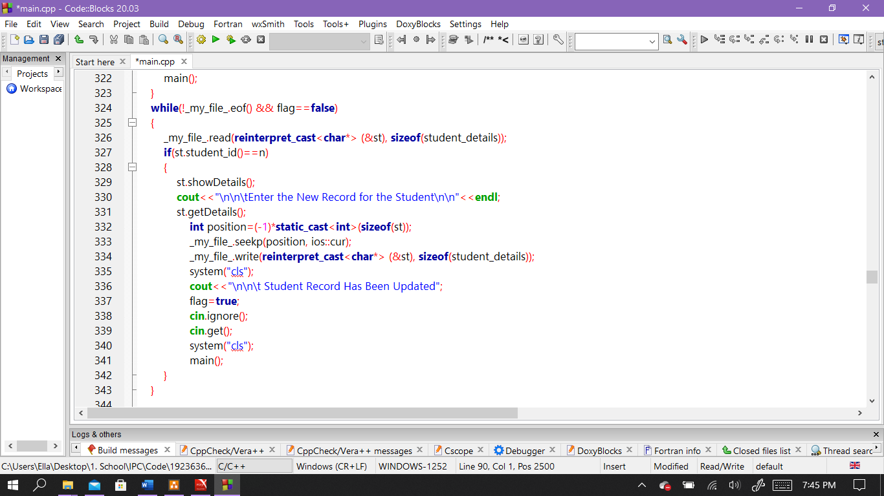

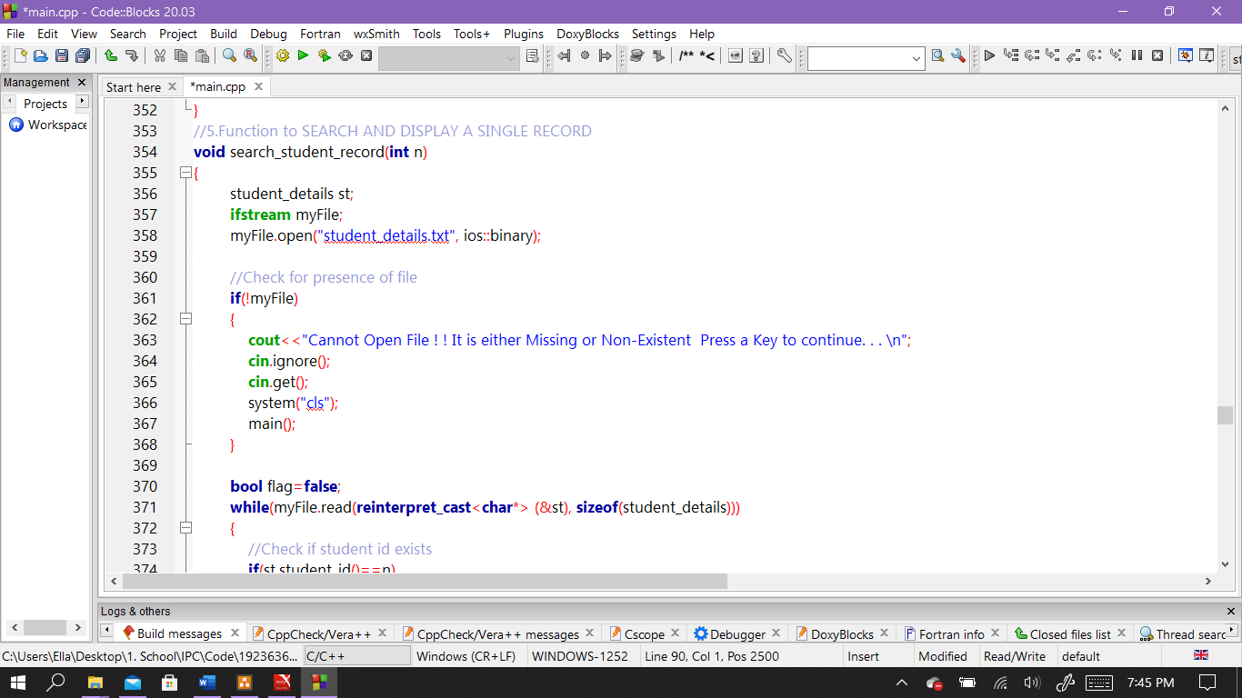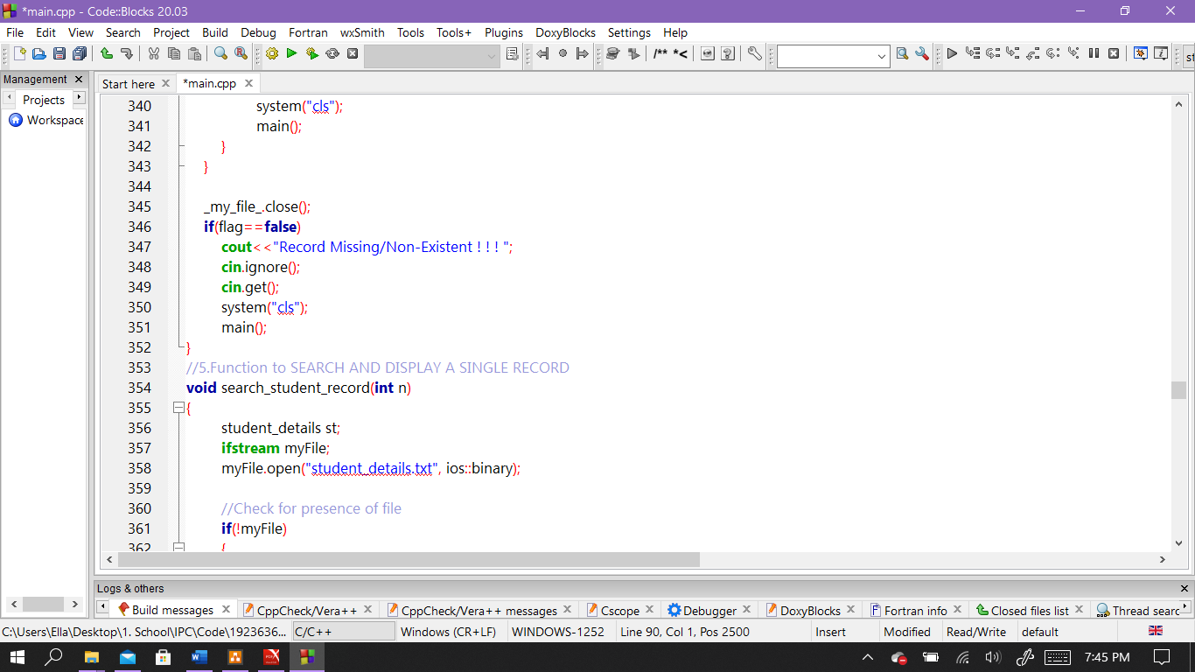

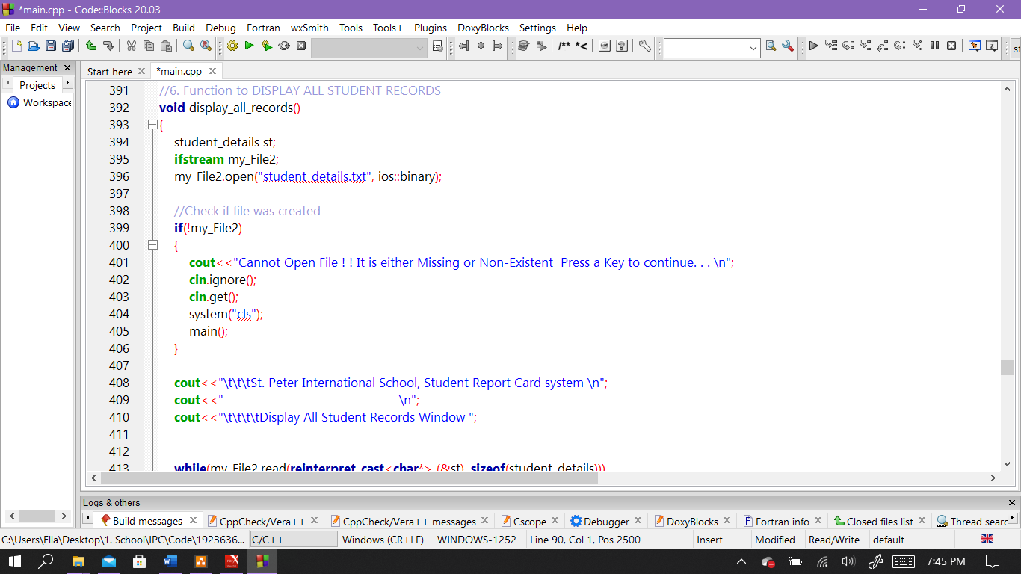

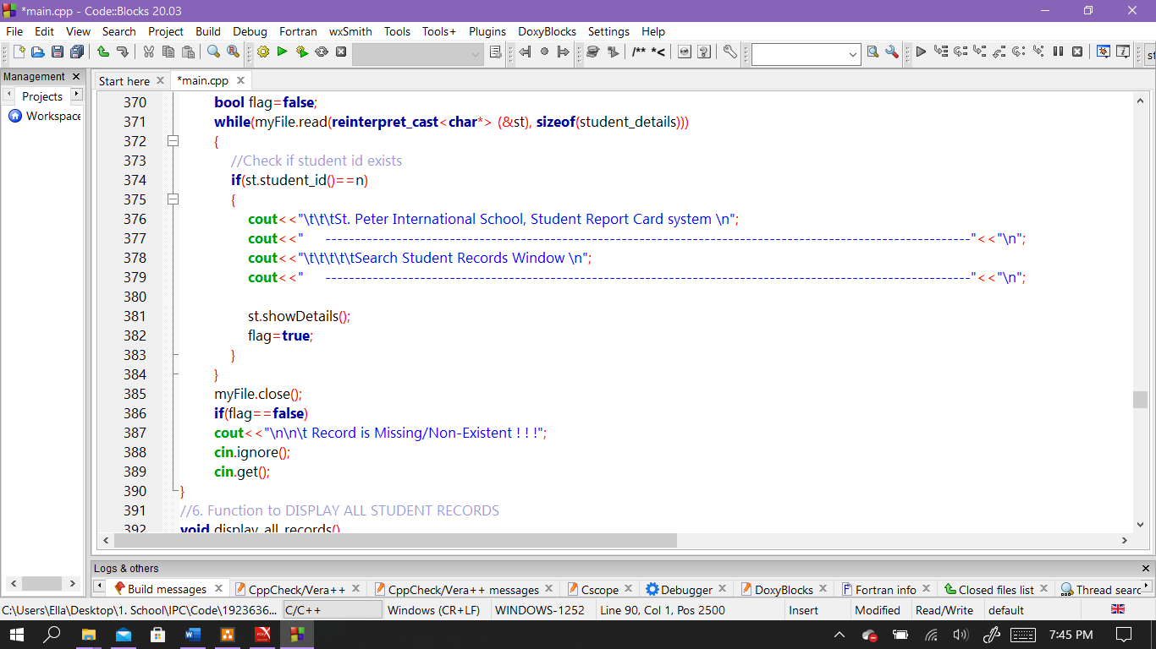

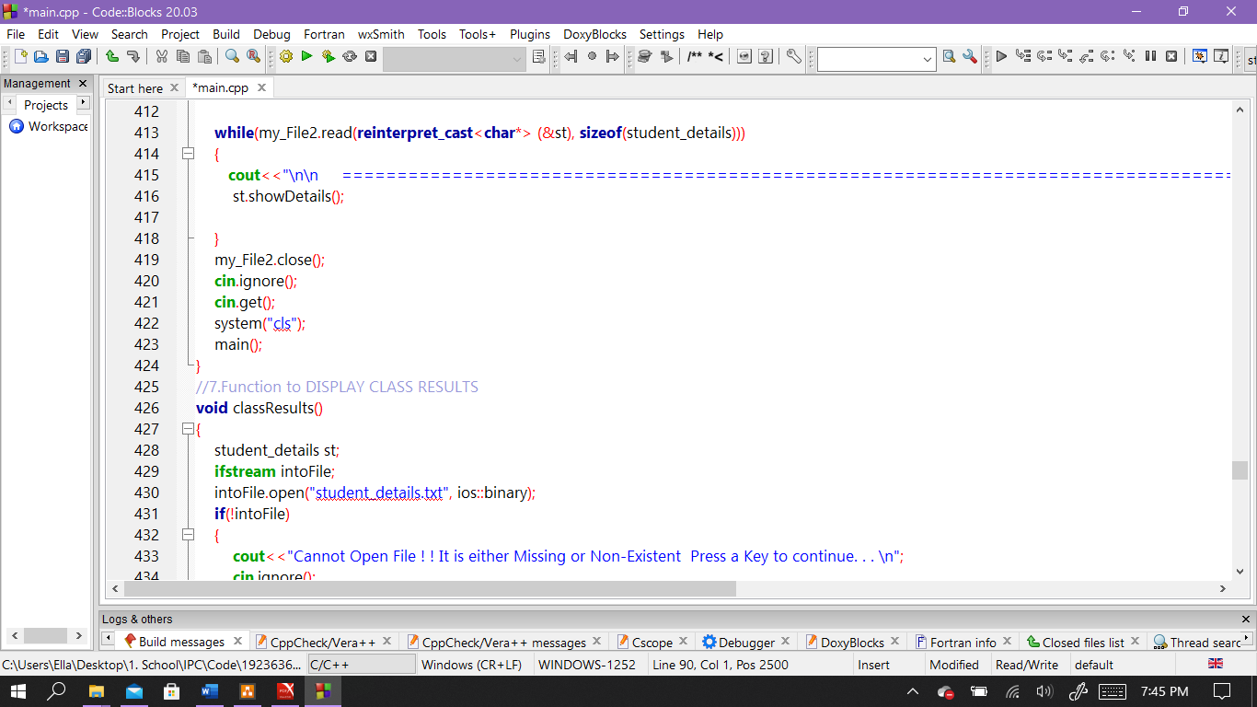

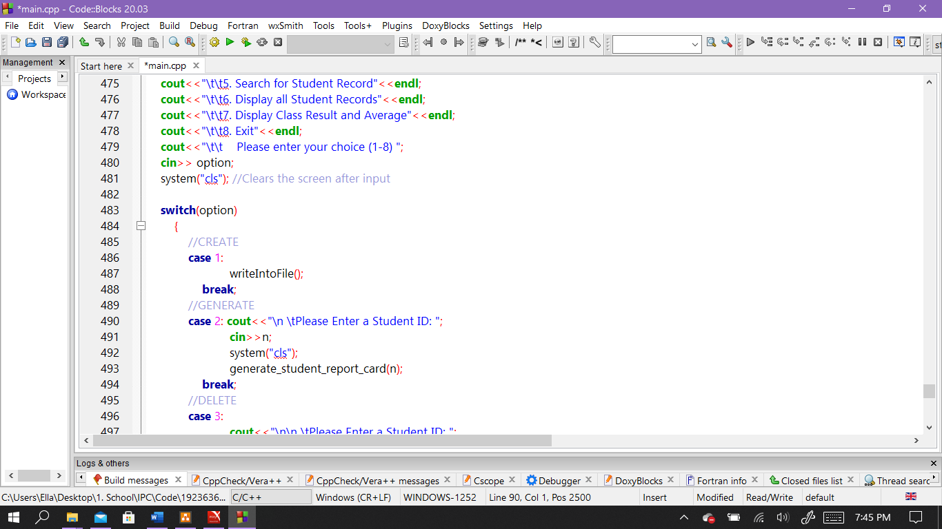

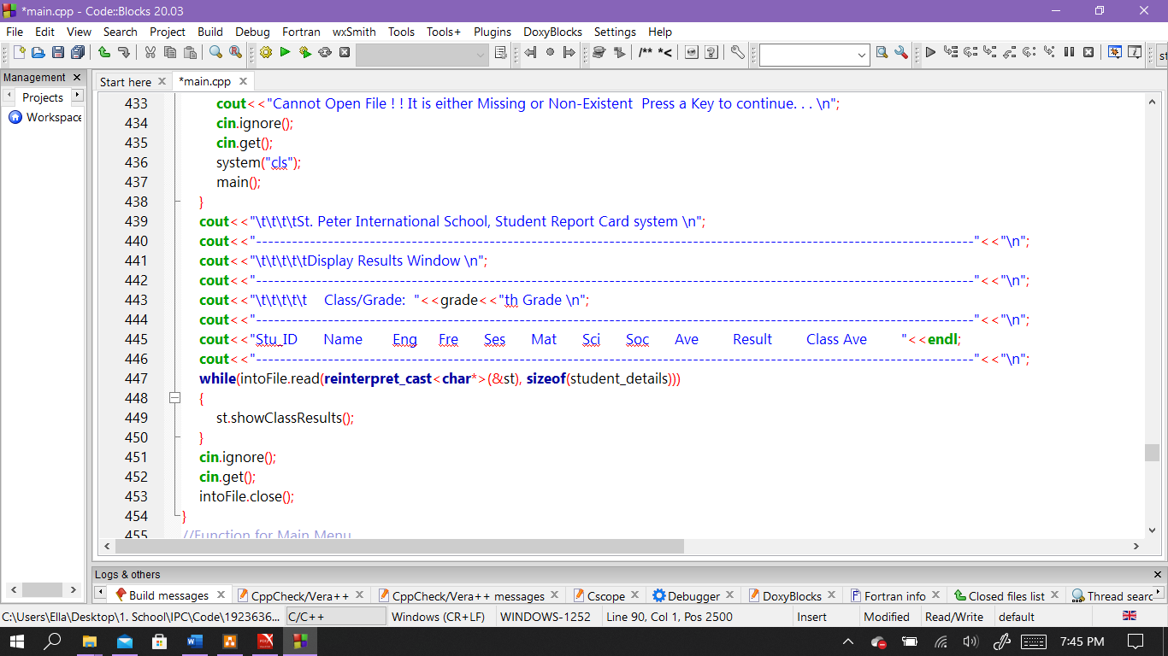

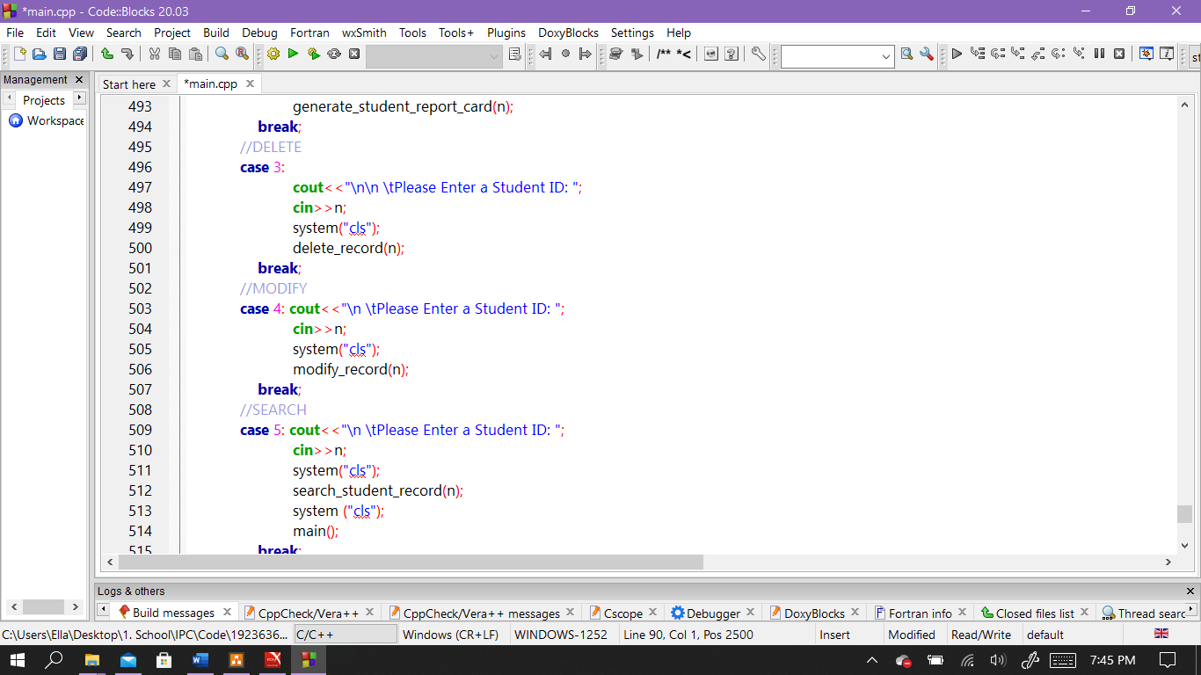

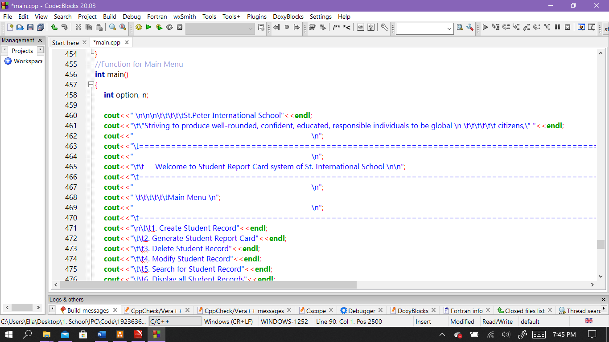

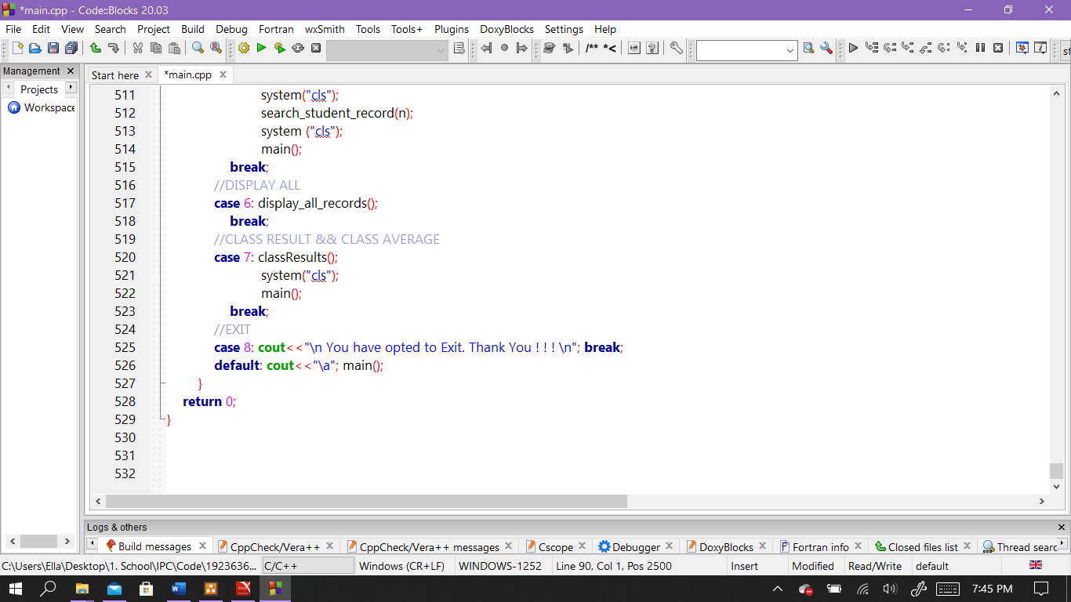

**Outcomes**

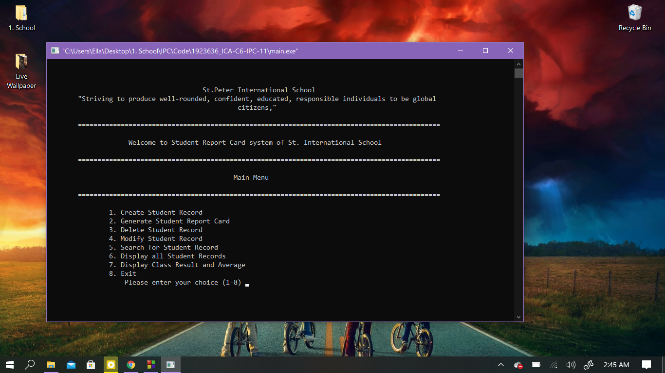Main Menu

This is the main menu.

After a user is done within an option, it automatically returns to the main menu. Any Key that is invalid still returns here unless they choose option 8, or in delete option where they can choose to exit directly.

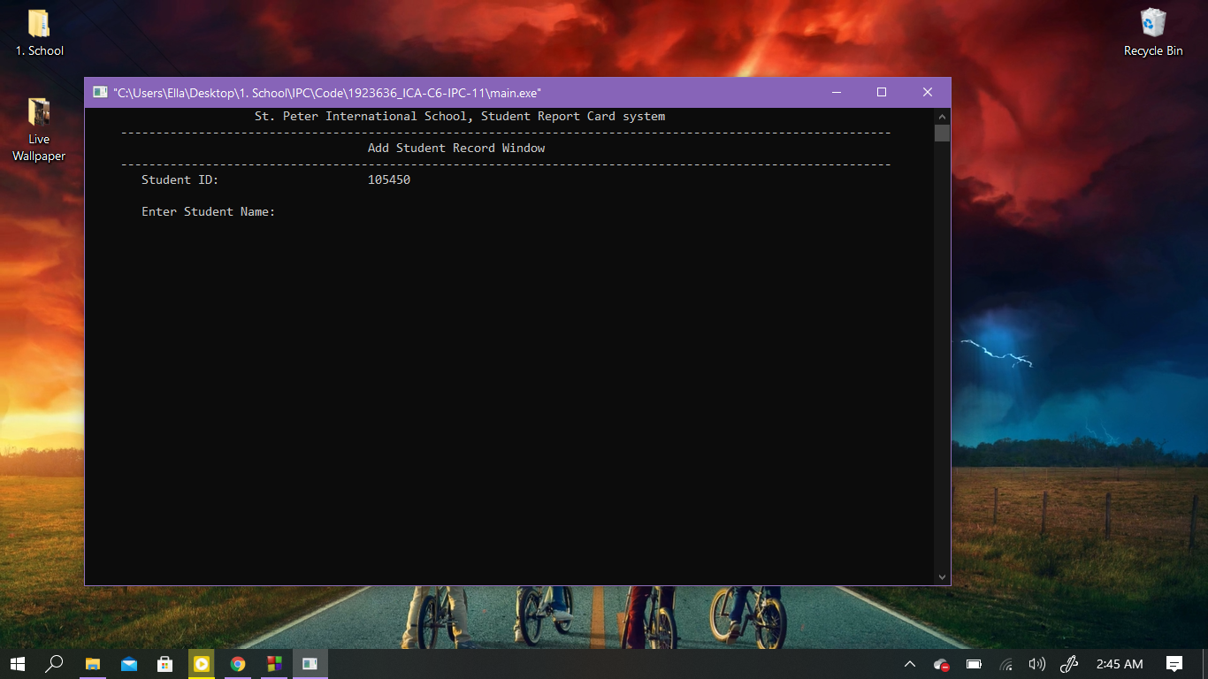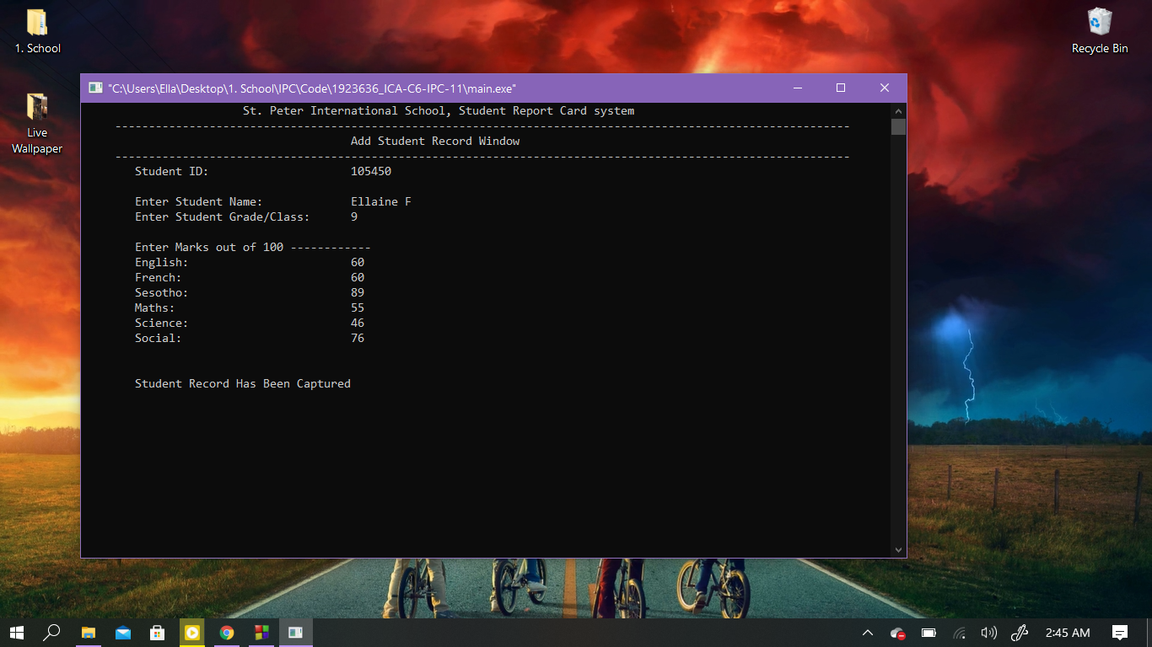

**Create Student record**

1. First the Student ID is auto generated
2. Second the user can input the student details
3. Lastly the user is notified the record has been added

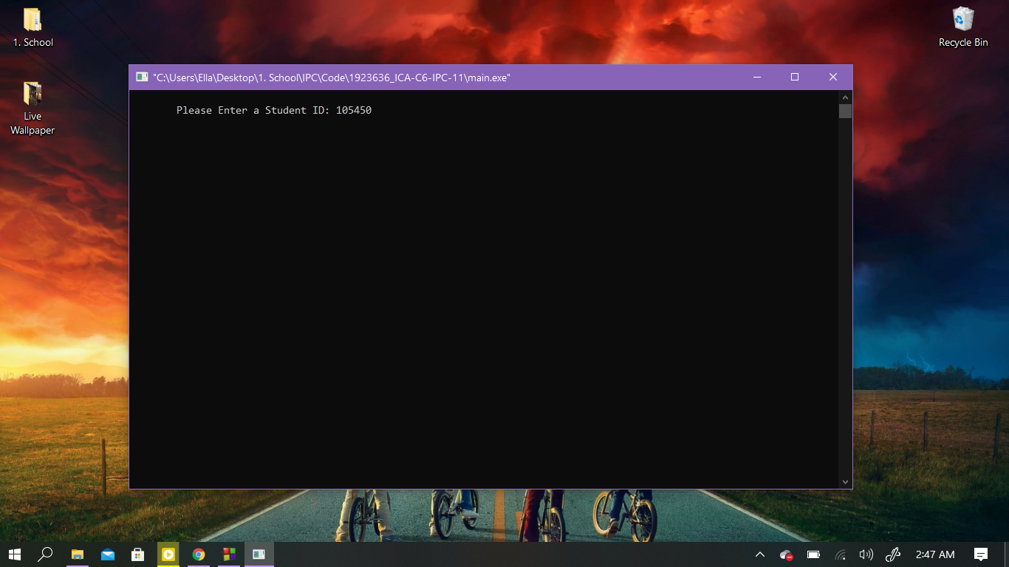

Student ID required to access record

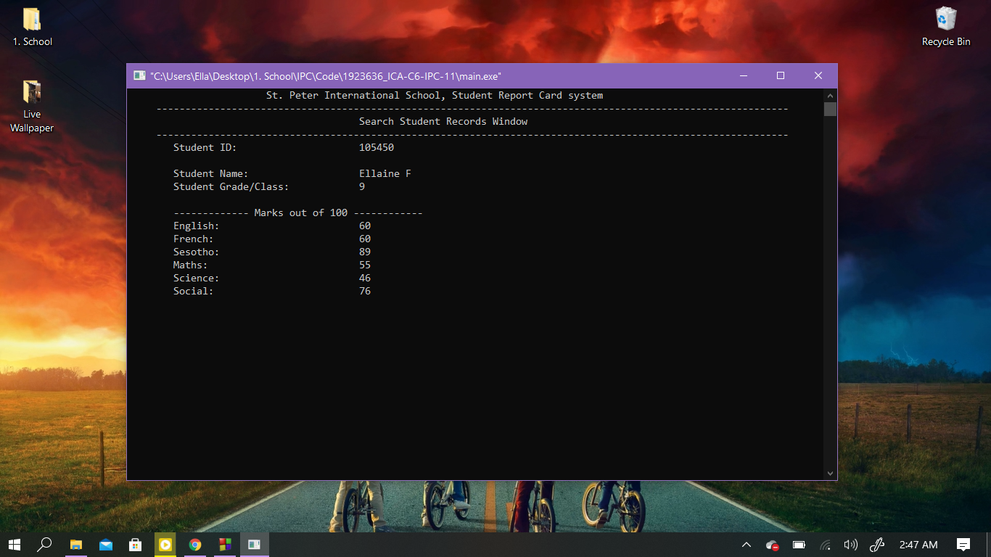

**Search Window**

For options 2 to 5, a student ID is required to retrieve the record.

The Search Window here shows the student’s data

After inputting student ID

Display All Window

The Display all window does not require a student ID authentication because it will show all the recorded data for students even if they are in different classes

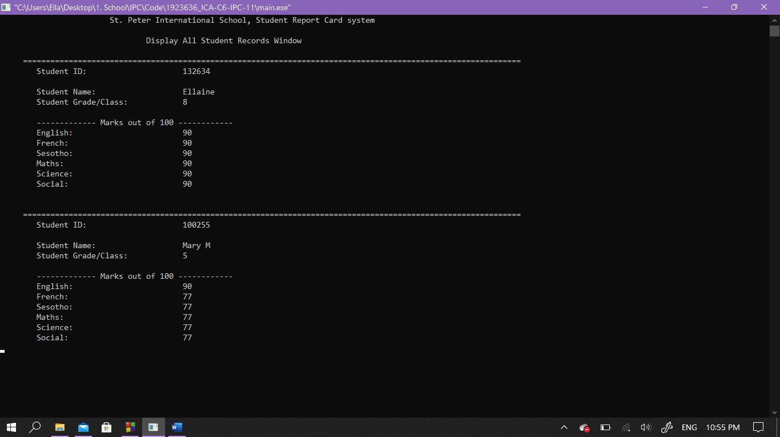

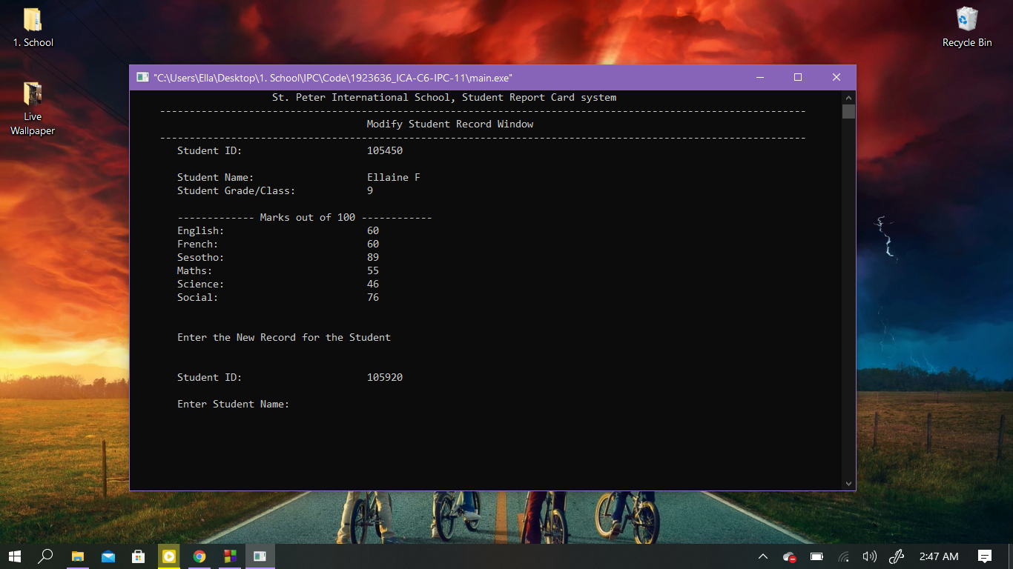Modification Window

* It first displays the record after inputting the student ID
* It then notifies the user to enter the new record
* Similar to the create record option, it recreates the record by accepting the new input from the user
* Lastly it notifies the user that the record has been updated.

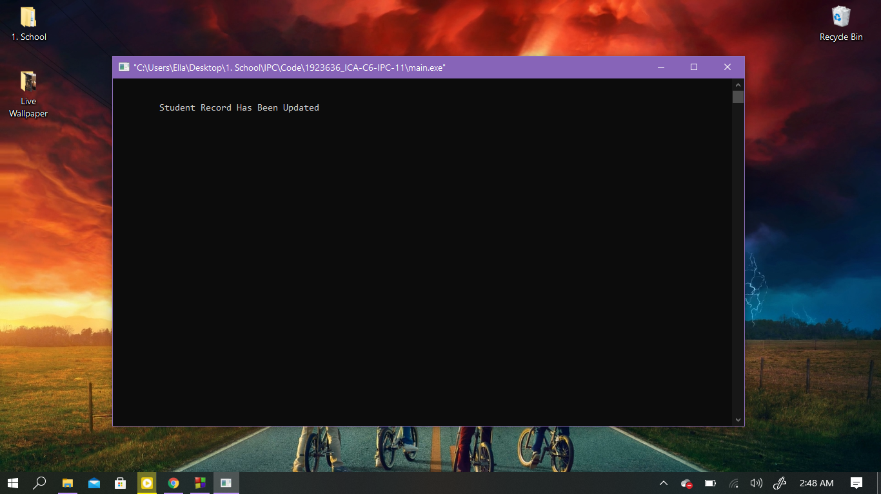Updation Notified Are You Sure Confirmation

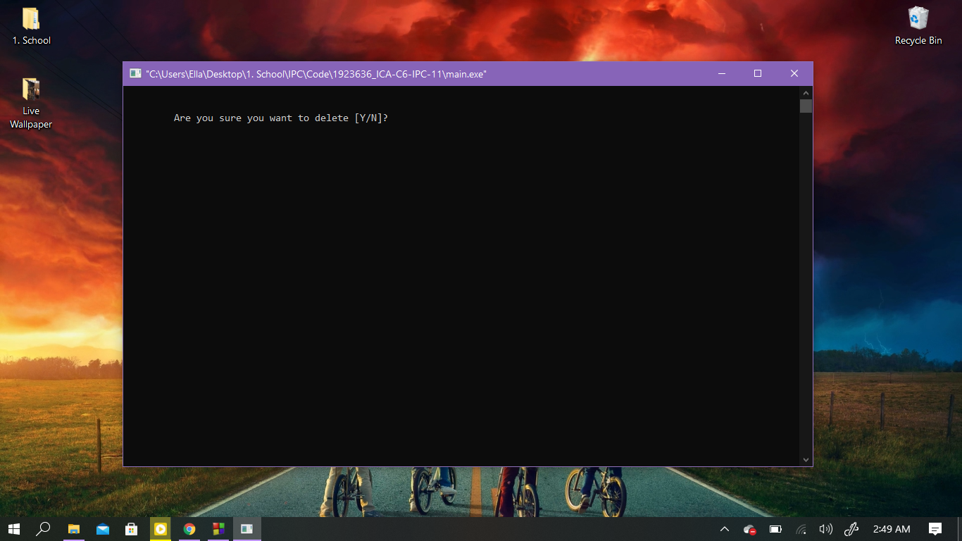

If yes – “Record deleted”

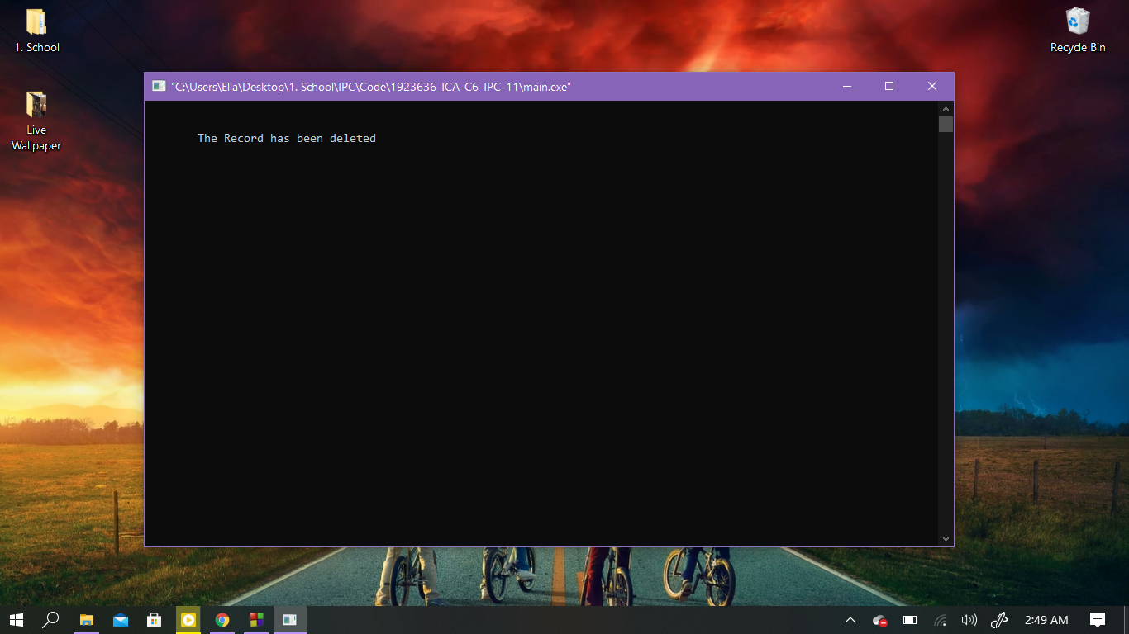message relayed If No – Opt to return to Menu or Exit

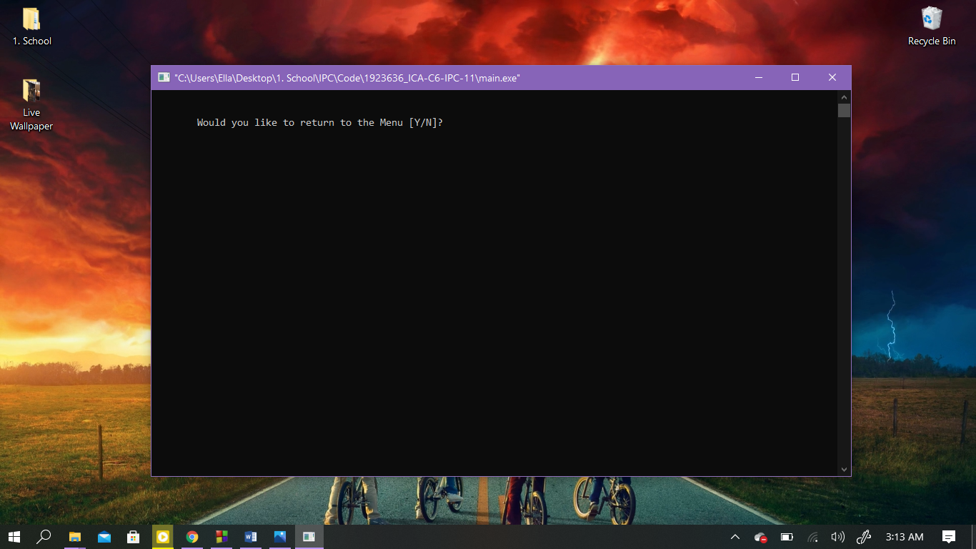

* When deleting, the user is asked whether or not they are sure they want to delete a record.
* If yes, they are notified the deletion was successful, if no, they are asked to exit or not.
* If a user chooses to exit, similar to the exit option in the main menu, a message is printed before asked to press continue and exit. Otherwise, the screen return to the main menu.

Exit Window

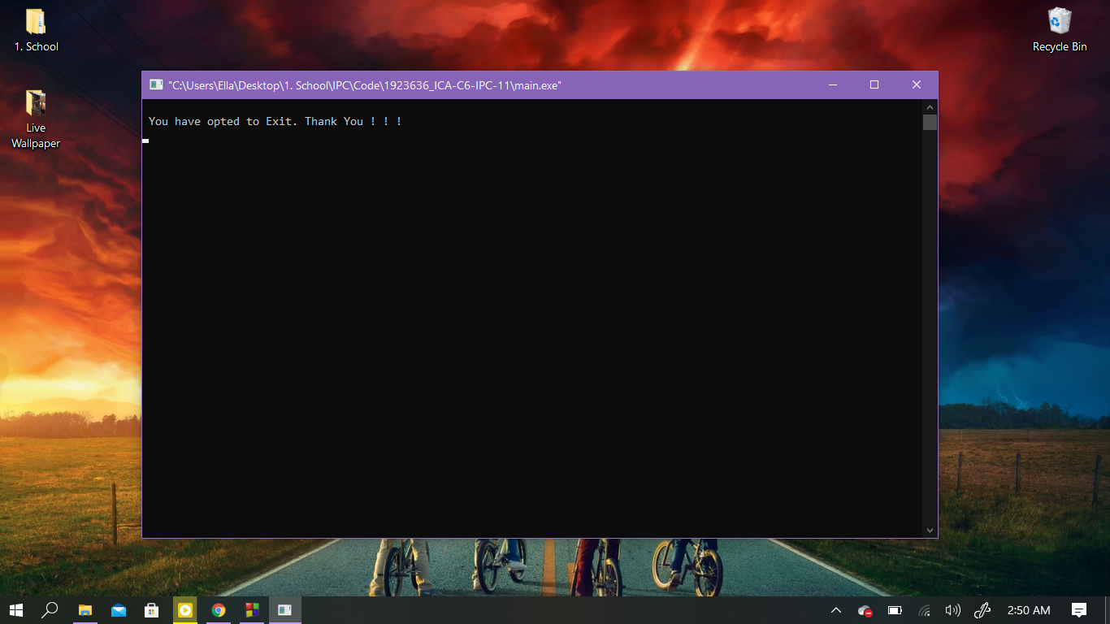

**5.Conclusion**

**Advantages and Disadvantages**

The system can reveal access to student’s information only if the user knows the student ID. However, if the student is the user, they are able to insert their ID in the system and change their marks. As an upgrade, perhaps the use of a teacher’s ID – only they and authority would know, is more suitable for security.

I found myself limited with my resources to come up with a way to auto generate the student ID. Eventually I ended up using random auto generator function. Unfortunately implementing this gave me a problem with option 4 – modifying a record. It would not replace the record, although it will notify the user that the record was updated.

Also, file handling was a serious problem in my side as it was very new and I only knew how to compile code blocks to create a file.

My resources included mostly YouTube videos as some websites were too difficult to understand. The next page includes some of these videos.

Overall, the system implements what the user requires except for a few features I was unsuccessful with.

# **References**

(n.d.). Retrieved December 14, 2020, from It SourceCode: https://itsourcecode.com/free-projects/cpluplus-projects/c-program-on-student-report-card-with-source-code/

Watch "C++ Program on Student Report Card With Source Code| C++ Projects with Source Code 2020" on Youtube. (2020, December 14). Retrieved from https://youtu.be/kc0Na_bFO_0

Source Code

(Watch "C++ Program on Student Report Card With Source Code| C++ Projects with Source Code 2020" on Youtube, 2020)

For Flowcharts –

(Watch "CIT1113-7078 Sept 19 2016 - functions and flowchart" on Youtube, 2021)